**TRƯỜNG ĐẠI HỌC TÀI NGUYÊN VÀ MÔI TRƯỜNG**

**THÀNH PHỐ HỒ CHÍ MINH**

**KHOA CÔNG NGHỆ THÔNG TIN**



**TỔNG HỢP LAB LẬP TRÌNH DI ĐỘNG**

Sinh viên thực hiện: Mai Nguyễn Trường Duy

Lớp: 11_ĐH_HTTT: 1150070006

Khóa: 2022 - 2026

Giảng viên hưỡng dẫn: ThS. Phạm Trọng Huynh

***TP. Hồ Chí Minh, tháng….12..năm…..2025***

**TRƯỜNG ĐẠI HỌC TÀI NGUYÊN VÀ MÔI TRƯỜNG THÀNH PHỐ HỒ CHÍ MINH**

**KHOA CÔNG NGHỆ THÔNG TIN**



**TỔNG HỢP LAB LẬP TRÌNH DI ĐỘNG**

Sinh viên thực hiện: Mai Nguyễn Trường Duy

Lớp: 11_ĐH_HTTT: 1150070006

Khóa: 2022 - 2026

Giảng viên hưỡng dẫn: ThS. Phạm Trọng Huynh

***TP. Hồ Chí Minh, tháng…12....năm ….2025***

**MỤC LỤC**

# BUỔI 1: BÀI TẬP THỰC HÀNH

## LAB_1

### BÀI TẬP_1

Tạo new project 🡪”Empty Views Activity” 🡪 Next 🡪 đặt tên file 🡪 finish

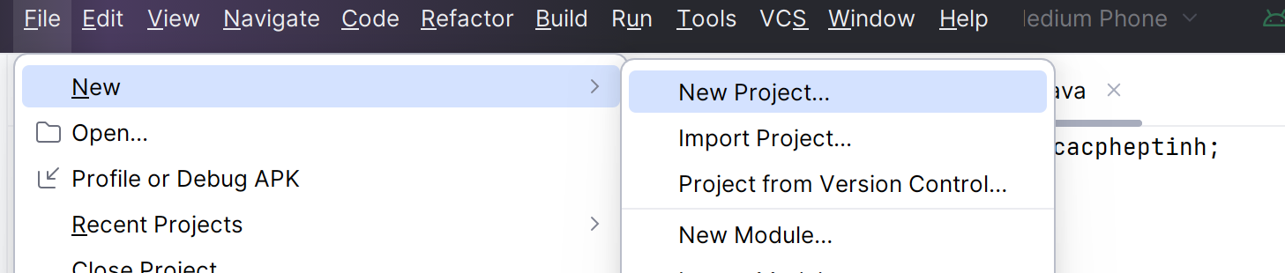

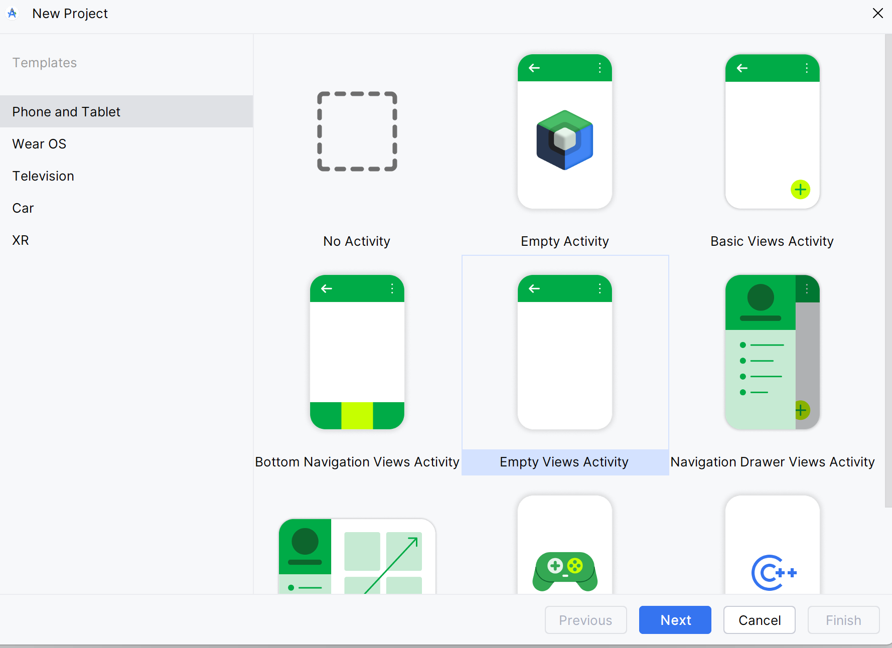

Vào file activity_main.xml🡪 đổi code cũ

|  |
| --- |
| *<?*xml version="1.0" encoding="utf-8"*?>* <LinearLayout xmlns:android="http://schemas.android.com/apk/res/android"  xmlns:tools="http://schemas.android.com/tools"  android:layout_width="match_parent"  android:layout_height="match_parent"  android:orientation="vertical"  android:gravity="center_horizontal"  android:padding="24dp"  android:background="#FAFAFA"  tools:context=".MainActivity">   <TextView  android:id="@+id/txtThongTin"  android:text="@string/thong_tin_sv"  android:textColor="#616161"  android:textSize="16sp"  android:gravity="center"  android:layout_width="match_parent"  android:layout_height="wrap_content"  android:layout_marginBottom="12dp" />   <TextView  android:id="@+id/txtTitle"  android:text="@string/title_app"  android:textColor="#00796B"  android:textSize="22sp"  android:textStyle="bold"  android:layout_marginBottom="20dp"  android:gravity="center"  android:layout_width="wrap_content"  android:layout_height="wrap_content" />   <EditText  android:id="@+id/edtA"  android:hint="@string/hint_so_a"  android:inputType="numberDecimal"  android:layout_width="match_parent"  android:layout_height="wrap_content"  android:layout_marginBottom="12dp" />   <EditText  android:id="@+id/edtB"  android:hint="@string/hint_so_b"  android:inputType="numberDecimal"  android:layout_width="match_parent"  android:layout_height="wrap_content"  android:layout_marginBottom="20dp" />   <LinearLayout  android:layout_width="match_parent"  android:layout_height="wrap_content"  android:orientation="horizontal"  android:gravity="center"  android:weightSum="5">   <Button  android:id="@+id/btnCong"  android:text="➕"  android:layout_weight="1"  android:layout_width="0dp"  android:layout_height="wrap_content"  android:backgroundTint="#4CAF50"  android:textColor="#FFF" />   <Button  android:id="@+id/btnTru"  android:text="➖"  android:layout_weight="1"  android:layout_width="0dp"  android:layout_height="wrap_content"  android:backgroundTint="#F44336"  android:textColor="#FFF"  android:layout_marginStart="8dp" />   <Button  android:id="@+id/btnNhan"  android:text="✖"  android:layout_weight="1"  android:layout_width="0dp"  android:layout_height="wrap_content"  android:backgroundTint="#2196F3"  android:textColor="#FFF"  android:layout_marginStart="8dp" />   <Button  android:id="@+id/btnChia"  android:text="➗"  android:layout_weight="1"  android:layout_width="0dp"  android:layout_height="wrap_content"  android:backgroundTint="#FF9800"  android:textColor="#FFF"  android:layout_marginStart="8dp" />   <Button  android:id="@+id/btnLamMoi"  android:text="🔄"  android:layout_weight="1"  android:layout_width="0dp"  android:layout_height="wrap_content"  android:backgroundTint="#9E9E9E"  android:textColor="#FFF"  android:layout_marginStart="8dp" />  </LinearLayout>   <TextView  android:id="@+id/txtKQ"  android:text="@string/ket_qua_mac_dinh"  android:textColor="#333333"  android:textStyle="italic"  android:textSize="18sp"  android:layout_marginTop="24dp"  android:gravity="center"  android:layout_width="match_parent"  android:layout_height="wrap_content" />  </LinearLayout> |

Tương tự như vậy trong MainActivity🡪 đổi code nội dung bên trong

|  |
| --- |
| package com.example.bt_thlab1;  import androidx.appcompat.app.AppCompatActivity;  import android.os.Bundle;  import android.view.View;  import android.widget.Button;  import android.widget.EditText;  import android.widget.TextView;  import android.widget.Toast;  public class MainActivity extends AppCompatActivity {  private EditText edtA, edtB;  private TextView txtKQ;  private Button btnCong, btnTru, btnNhan, btnChia, btnLamMoi;  @Override  protected void onCreate(Bundle savedInstanceState) {  super.onCreate(savedInstanceState);  setContentView(R.layout.activity_main);  edtA = findViewById(R.id.edtA);  edtB = findViewById(R.id.edtB);  txtKQ = findViewById(R.id.txtKQ);  btnCong = findViewById(R.id.btnCong);  btnTru = findViewById(R.id.btnTru);  btnNhan = findViewById(R.id.btnNhan);  btnChia = findViewById(R.id.btnChia);  btnLamMoi = findViewById(R.id.btnLamMoi);  View.OnClickListener listener = v -> {  try {  double a = Double.parseDouble(edtA.getText().toString());  double b = Double.parseDouble(edtB.getText().toString());  double kq = 0;  int id = v.getId();  if (id == R.id.btnCong) {  kq = a + b;  } else if (id == R.id.btnTru) {  kq = a - b;  } else if (id == R.id.btnNhan) {  kq = a * b;  } else if (id == R.id.btnChia) {  if (b == 0) {  Toast.makeText(this, "❌ Không thể chia cho 0!", Toast.LENGTH_SHORT).show();  return;  }  kq = a / b;  } else if (id == R.id.btnLamMoi) {  edtA.setText("");  edtB.setText("");  txtKQ.setText(getString(R.string.ket_qua_mac_dinh));  Toast.makeText(this, "🔄 Đã làm mới!", Toast.LENGTH_SHORT).show();  return;  }  txtKQ.setText("✅ Kết quả: " + kq);  } catch (NumberFormatException e) {  Toast.makeText(this, "⚠️ Nhập đủ và đúng định dạng số!", Toast.LENGTH_SHORT).show();  }  };  btnCong.setOnClickListener(listener);  btnTru.setOnClickListener(listener);  btnNhan.setOnClickListener(listener);  btnChia.setOnClickListener(listener);  btnLamMoi.setOnClickListener(listener);  }  } |

Trong values 🡪 string.xml mình sẽ gán vào

|  |
| --- |
| <resources>  <string name="app_name">Bt_thlab1</string>  <string name="title_app">✨ Máy Tính Cơ Bản ✨</string>  <string name="hint_so_a">Nhập số a</string>  <string name="hint_so_b">Nhập số b</string>  <string name="ket_qua_mac_dinh">Kết quả sẽ hiển thị ở đây</string>  <string name="thong_tin_sv">Họ tên: Mai Nguyễn Trường Duy 🌸&#10;Mã SV: 1150070006&#10;Lớp: 11_ĐH_TMĐT</string>  </resources> |

Sau đó run🡪 chạy ra kết quả

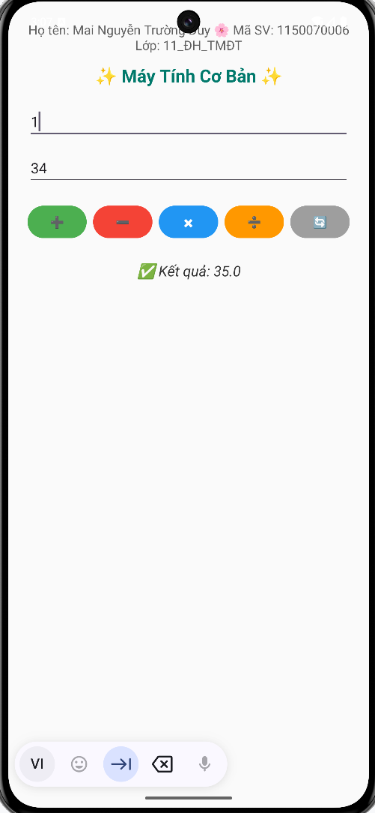

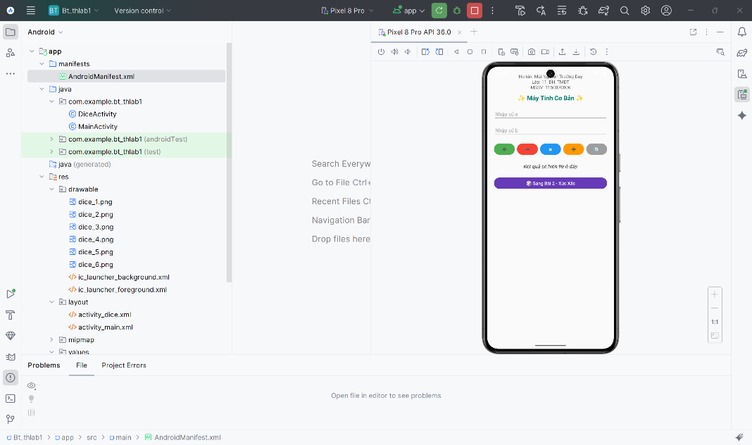

### BÀI TẬP_2

Tải ảnh của 6 xúc Xắc 🡪 cho vào file “drawable”

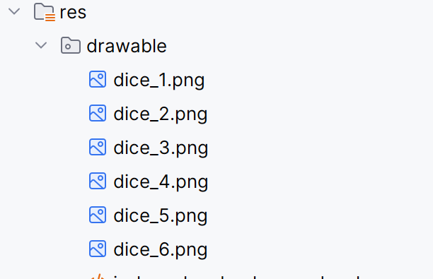

Tạo file mới 🡪 activity_dice.xml

|  |
| --- |
| <?xml version="1.0" encoding="utf-8"?>  <LinearLayout xmlns:android="http://schemas.android.com/apk/res/android"  xmlns:tools="http://schemas.android.com/tools"  android:layout_width="match_parent"  android:layout_height="match_parent"  android:orientation="vertical"  android:gravity="center"  android:padding="24dp"  android:background="#FFF8E1"  tools:context=".DiceActivity">  <TextView  android:text="🎲 Xúc Xắc May Mắn 🎲"  android:textSize="24sp"  android:textColor="#E91E63"  android:textStyle="bold"  android:layout_marginBottom="20dp"  android:gravity="center"  android:layout_width="wrap_content"  android:layout_height="wrap_content" />  <ImageView  android:id="@+id/imgDice"  android:src="@drawable/dice_1"  android:layout_width="180dp"  android:layout_height="180dp"  android:layout_marginBottom="20dp"  android:contentDescription="Dice Image" />  <Button  android:id="@+id/btnRoll"  android:text="🎯 Tung Xúc Xắc"  android:layout_width="match_parent"  android:layout_height="wrap_content"  android:backgroundTint="#4CAF50"  android:textColor="#FFFFFF"  android:textSize="18sp"  android:layout_marginBottom="16dp" />  <TextView  android:id="@+id/txtKetQua"  android:text="Kết quả: chưa tung 🎲"  android:textSize="18sp"  android:textColor="#333333"  android:gravity="center"  android:layout_marginBottom="20dp"  android:layout_width="wrap_content"  android:layout_height="wrap_content" />  <Button  android:id="@+id/btnBack"  android:text="⬅ Quay lại Máy Tính"  android:layout_width="match_parent"  android:layout_height="wrap_content"  android:backgroundTint="#9E9E9E"  android:textColor="#FFFFFF" />  </LinearLayout> |

Thêm file mới “DiceActivity” 🡪 thêm nội dung code

|  |
| --- |
| package com.example.bt_thlab1;  import android.content.Intent;  import android.os.Bundle;  import android.os.Handler;  import android.os.Vibrator;  import android.view.animation.Animation;  import android.view.animation.RotateAnimation;  import android.widget.Button;  import android.widget.ImageView;  import android.widget.TextView;  import androidx.appcompat.app.AppCompatActivity;  import java.util.Random;  public class DiceActivity extends AppCompatActivity {  private ImageView imgDice;  private TextView txtKetQua;  private Button btnRoll, btnBack;  private final Random random = new Random();  @Override  protected void onCreate(Bundle savedInstanceState) {  super.onCreate(savedInstanceState);  setContentView(R.layout.activity_dice);  imgDice = findViewById(R.id.imgDice);  txtKetQua = findViewById(R.id.txtKetQua);  btnRoll = findViewById(R.id.btnRoll);  btnBack = findViewById(R.id.btnBack);  btnRoll.setOnClickListener(v -> rollDice());  btnBack.setOnClickListener(v -> {  Intent intent = new Intent(DiceActivity.this, MainActivity.class);  startActivity(intent);  finish();  });  }  private void rollDice() {  RotateAnimation rotate = new RotateAnimation(  0, 720,  Animation.RELATIVE_TO_SELF, 0.5f,  Animation.RELATIVE_TO_SELF, 0.5f  );  rotate.setDuration(600);  imgDice.startAnimation(rotate);  Vibrator vibrator = (Vibrator) getSystemService(VIBRATOR_SERVICE);  if (vibrator != null) {  vibrator.vibrate(200);  }  new Handler().postDelayed(() -> {  int value = random.nextInt(6) + 1;  int resId = getResources().getIdentifier("dice_" + value, "drawable", getPackageName());  imgDice.setImageResource(resId);  txtKetQua.setText("🎲 Kết quả: " + value);  }, 600);  }  } |

Trong Manifest 🡪 thêm file dẫn để chạy ra đường dẫn

|  |
| --- |
| <?xml version="1.0" encoding="utf-8"?>  <manifest xmlns:android="http://schemas.android.com/apk/res/android"  xmlns:tools="http://schemas.android.com/tools">  <uses-permission android:name="android.permission.VIBRATE" />  <application  android:allowBackup="true"  android:dataExtractionRules="@xml/data_extraction_rules"  android:fullBackupContent="@xml/backup_rules"  android:icon="@mipmap/ic_launcher"  android:label="@string/app_name"  android:roundIcon="@mipmap/ic_launcher_round"  android:supportsRtl="true"  android:theme="@style/Theme.Bt_thlab1"  tools:targetApi="31">  <activity  android:name=".MainActivity"  android:exported="true">  <intent-filter>  <action android:name="android.intent.action.MAIN" />  <category android:name="android.intent.category.LAUNCHER" />  </intent-filter>  </activity>  <activity  android:name=".DiceActivity"  android:exported="false" />  </application>  </manifest> |

Run 🡪 chạy ra kết quả

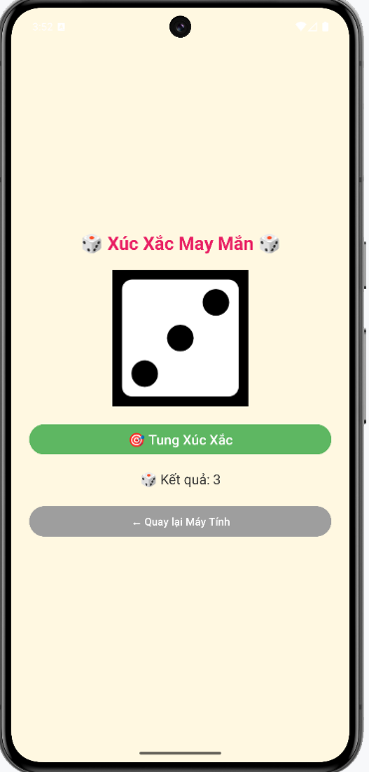

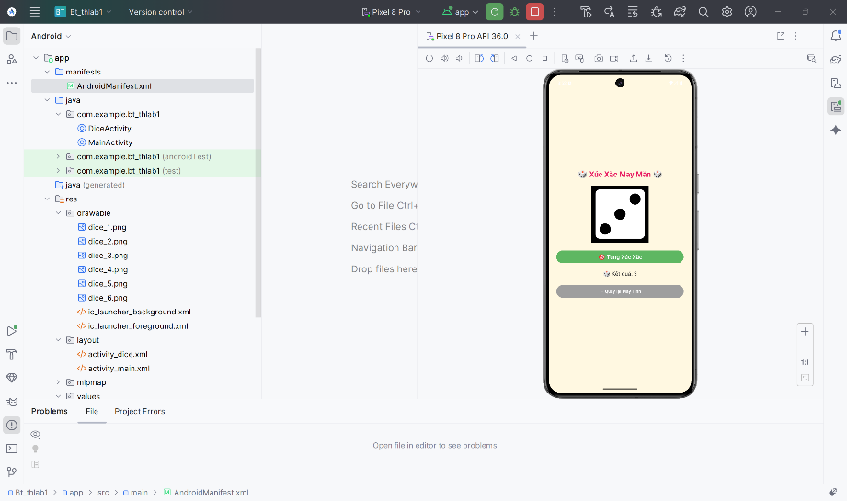

### BÀI TẬP_3

Tạo file mới “CallSmsActivity”

|  |
| --- |
| package com.example.bt_thlab1;  import android.content.Intent;  import android.net.Uri;  import android.os.Bundle;  import android.os.Vibrator;  import android.widget.Button;  import android.widget.EditText;  import android.widget.Toast;  import androidx.appcompat.app.AppCompatActivity;  public class CallSmsActivity extends AppCompatActivity {  private EditText edtPhone, edtMessage;  private Button btnCall, btnSms, btnBack;  @Override  protected void onCreate(Bundle savedInstanceState) {  super.onCreate(savedInstanceState);  setContentView(R.layout.activity_call_sms);  edtPhone = findViewById(R.id.edtPhone);  edtMessage = findViewById(R.id.edtMessage);  btnCall = findViewById(R.id.btnCall);  btnSms = findViewById(R.id.btnSms);  btnBack = findViewById(R.id.btnBack);  btnCall.setOnClickListener(v -> {  String phone = edtPhone.getText().toString().trim();  if (phone.isEmpty()) {  Toast.makeText(this, "⚠️ Nhập số điện thoại trước khi gọi!", Toast.LENGTH_SHORT).show();  return;  }  Vibrator vib = (Vibrator) getSystemService(VIBRATOR_SERVICE);  if (vib != null) vib.vibrate(100);  Intent callIntent = new Intent(Intent.ACTION_DIAL, Uri.parse("tel:" + phone));  startActivity(callIntent);  });  btnSms.setOnClickListener(v -> {  String phone = edtPhone.getText().toString().trim();  String msg = edtMessage.getText().toString().trim();  if (phone.isEmpty() || msg.isEmpty()) {  Toast.makeText(this, "⚠️ Nhập số điện thoại và nội dung tin nhắn!", Toast.LENGTH_SHORT).show();  return;  }  Vibrator vib = (Vibrator) getSystemService(VIBRATOR_SERVICE);  if (vib != null) vib.vibrate(100);  Intent smsIntent = new Intent(Intent.ACTION_VIEW, Uri.fromParts("sms", phone, null));  smsIntent.putExtra("sms_body", msg);  startActivity(smsIntent);  });  btnBack.setOnClickListener(v -> finish());  }  } |

Tiếp theo tạo file “activity_call_sms.xml”

|  |
| --- |
| <?xml version="1.0" encoding="utf-8"?>  <LinearLayout xmlns:android="http://schemas.android.com/apk/res/android"  xmlns:tools="http://schemas.android.com/tools"  android:layout_width="match_parent"  android:layout_height="match_parent"  android:orientation="vertical"  android:gravity="center_horizontal"  android:padding="24dp"  android:background="#F2F8FF"  tools:context=".CallSmsActivity">  <TextView  android:text="📱 Liên Lạc Nhanh"  android:textSize="22sp"  android:textColor="#1565C0"  android:textStyle="bold"  android:layout_marginBottom="24dp"  android:gravity="center"  android:layout_width="wrap_content"  android:layout_height="wrap_content" />  <EditText  android:id="@+id/edtPhone"  android:hint="Nhập số điện thoại..."  android:inputType="phone"  android:layout_width="match_parent"  android:layout_height="wrap_content"  android:background="@drawable/edit_bg"  android:padding="12dp"  android:layout_marginBottom="16dp" />  <EditText  android:id="@+id/edtMessage"  android:hint="Nhập nội dung tin nhắn..."  android:inputType="textMultiLine"  android:minLines="3"  android:gravity="top"  android:layout_width="match_parent"  android:layout_height="wrap_content"  android:background="@drawable/edit_bg"  android:padding="12dp"  android:layout_marginBottom="24dp" />  <LinearLayout  android:layout_width="match_parent"  android:layout_height="wrap_content"  android:orientation="horizontal"  android:weightSum="2"  android:layout_marginBottom="16dp">  <Button  android:id="@+id/btnCall"  android:text="📞 Gọi"  android:layout_width="0dp"  android:layout_height="wrap_content"  android:layout_weight="1"  android:backgroundTint="#4CAF50"  android:textColor="#FFFFFF"  android:textSize="16sp" />  <Button  android:id="@+id/btnSms"  android:text="💬 Nhắn"  android:layout_width="0dp"  android:layout_height="wrap_content"  android:layout_weight="1"  android:layout_marginStart="12dp"  android:backgroundTint="#2196F3"  android:textColor="#FFFFFF"  android:textSize="16sp" />  </LinearLayout>  <Button  android:id="@+id/btnBack"  android:text="⬅ Quay lại Menu"  android:layout_width="match_parent"  android:layout_height="wrap_content"  android:backgroundTint="#9E9E9E"  android:textColor="#FFFFFF"  android:textSize="15sp" />  </LinearLayout> |

AndroidManifest 🡪 chèn thêm file dẫn vào

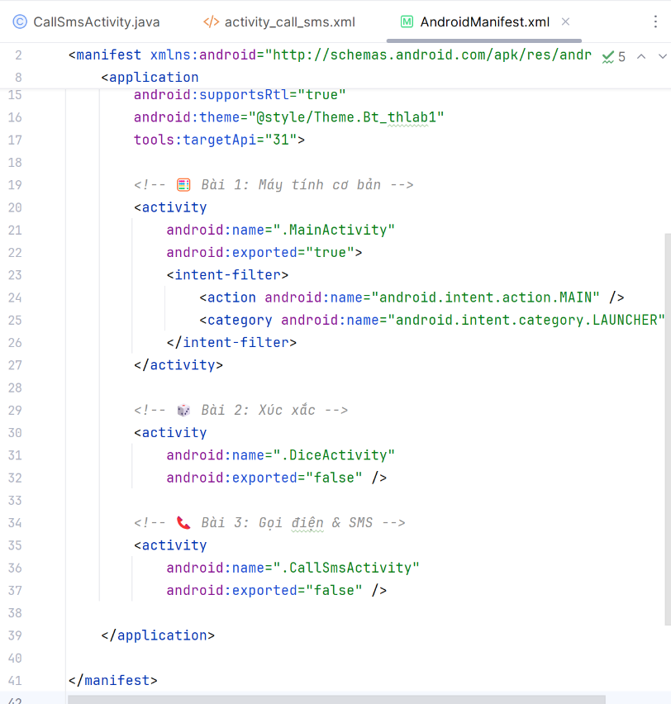

Run chạy ra kết quả

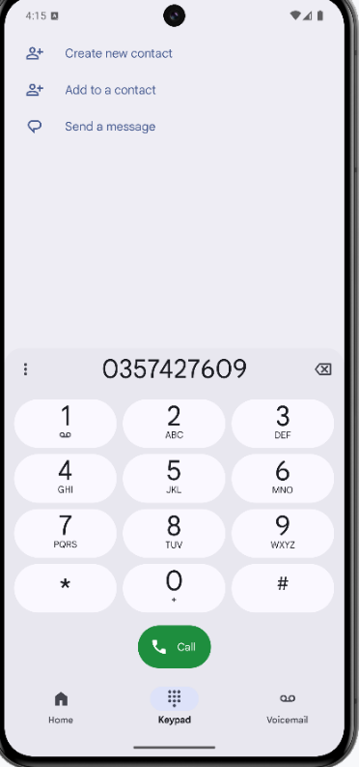

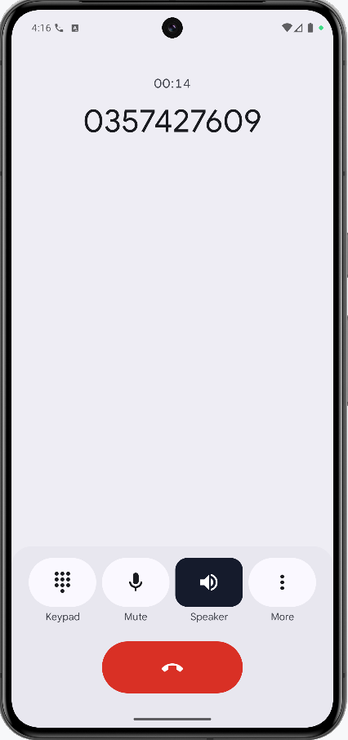

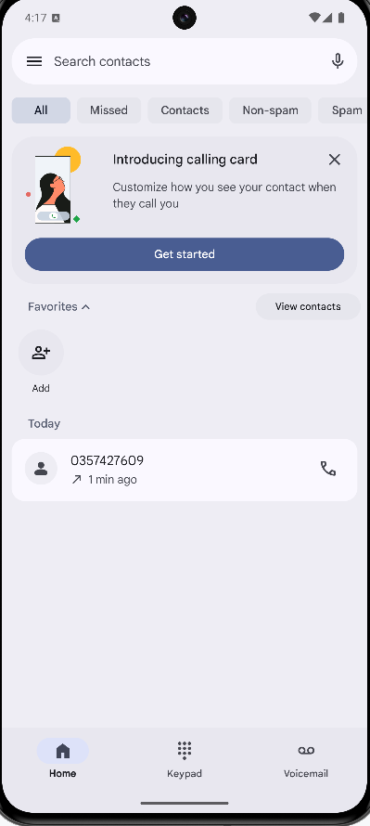

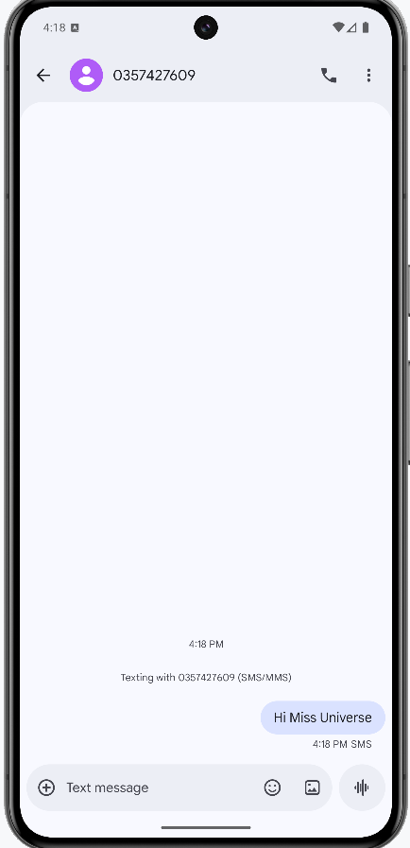

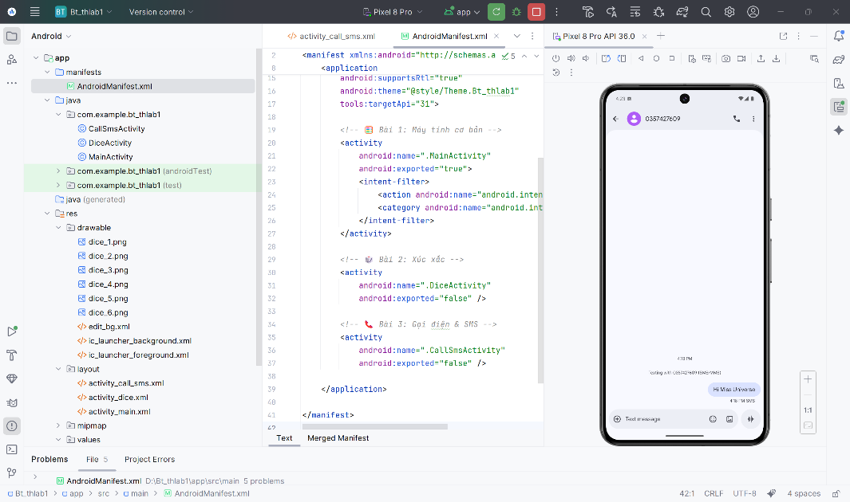

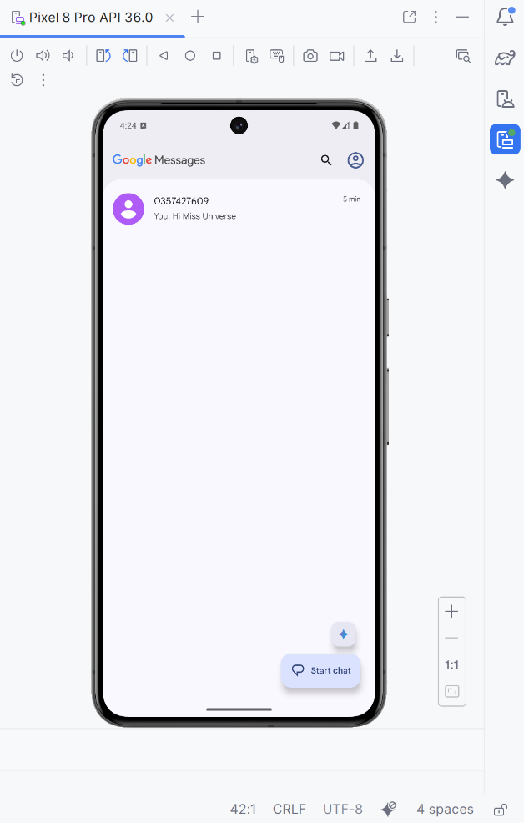

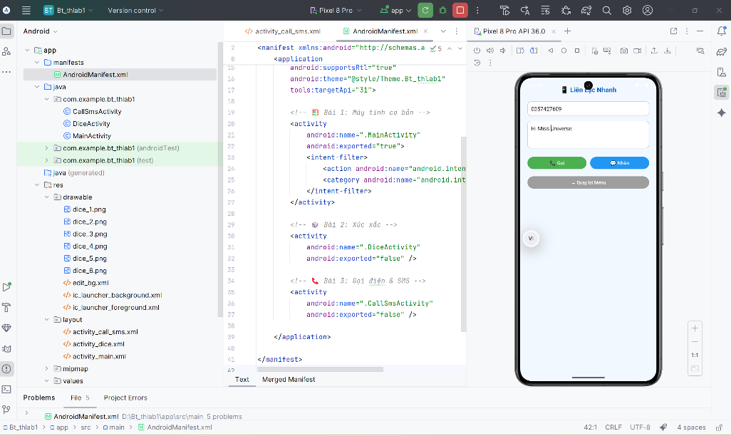

## LAB_2

### BÀI TẬP_1

Tải 5 icon về máy 🡪 cho vào mục file drawable

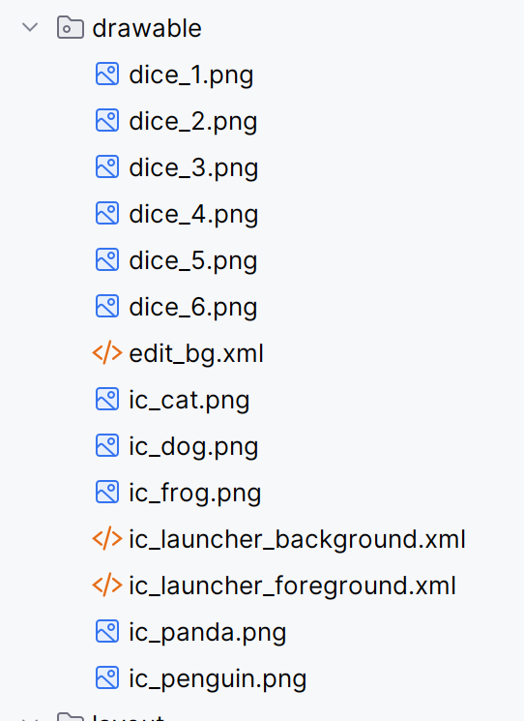

Tạo file SplashActivity.java

|  |
| --- |
| package com.example.bt_thlab1;  import android.content.Intent;  import android.graphics.Color;  import android.os.Bundle;  import android.os.Handler;  import android.view.animation.AlphaAnimation;  import android.widget.ImageView;  import android.widget.LinearLayout;  import android.widget.TextView;  import androidx.appcompat.app.AppCompatActivity;  import java.util.Random;  public class SplashActivity extends AppCompatActivity {  @Override  protected void onCreate(Bundle savedInstanceState) {  super.onCreate(savedInstanceState);  setContentView(R.layout.activity_splash);  LinearLayout layout = findViewById(R.id.layoutSplash);  ImageView img = findViewById(R.id.imgAnimal);  TextView txt = findViewById(R.id.txtTitle);  int[] colors = {  Color.parseColor("#64B5F6"),  Color.parseColor("#BA68C8"),  Color.parseColor("#4DB6AC"),  Color.parseColor("#FFB74D"),  Color.parseColor("#F48FB1")  };  int[] icons = {  R.drawable.ic_penguin,  R.drawable.ic_panda,  R.drawable.ic_dog,  R.drawable.ic_cat,  R.drawable.ic_frog  };  Random r = new Random();  int color = colors[r.nextInt(colors.length)];  int icon = icons[r.nextInt(icons.length)];  layout.setBackgroundColor(color);  img.setImageResource(icon);  AlphaAnimation fadeIn = new AlphaAnimation(0f, 1f);  fadeIn.setDuration(1500);  img.startAnimation(fadeIn);  txt.startAnimation(fadeIn);  new Handler().postDelayed(() -> {  Intent i = new Intent(SplashActivity.this, MainActivity.class);  startActivity(i);  finish();  }, 3000);  }  } |

File xml tạo activity_splash.xml

|  |
| --- |
| <?xml version="1.0" encoding="utf-8"?>  <LinearLayout xmlns:android="http://schemas.android.com/apk/res/android"  xmlns:tools="http://schemas.android.com/tools"  android:id="@+id/layoutSplash"  android:layout_width="match_parent"  android:layout_height="match_parent"  android:gravity="center"  android:orientation="vertical"  android:background="@color/white"  tools:context=".SplashActivity">  <ImageView  android:id="@+id/imgAnimal"  android:layout_width="140dp"  android:layout_height="140dp"  android:src="@drawable/ic_penguin"  android:contentDescription="@string/app_name" />  <TextView  android:id="@+id/txtTitle"  android:layout_width="wrap_content"  android:layout_height="wrap_content"  android:text="Animal Sound"  android:textColor="#FFFFFF"  android:textSize="26sp"  android:textStyle="bold"  android:layout_marginTop="16dp" />  </LinearLayout> |

Thêm file chèn trong AndroidManifest

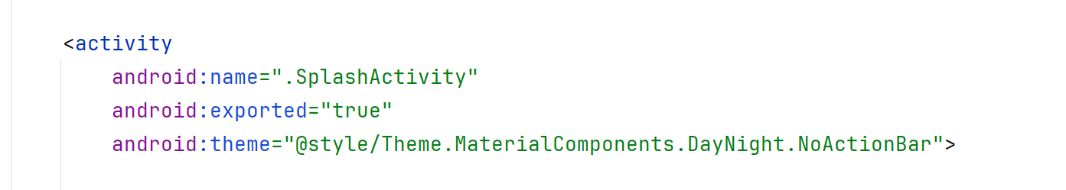

Run chạy test kết quả

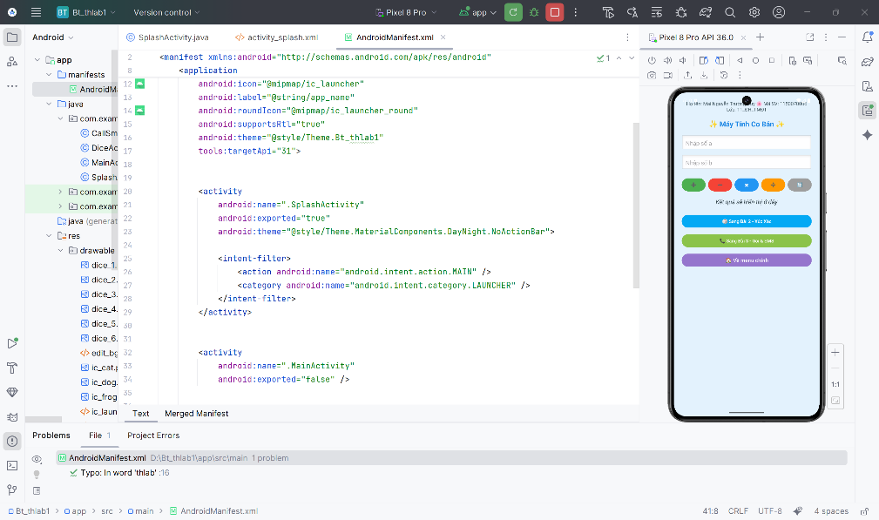

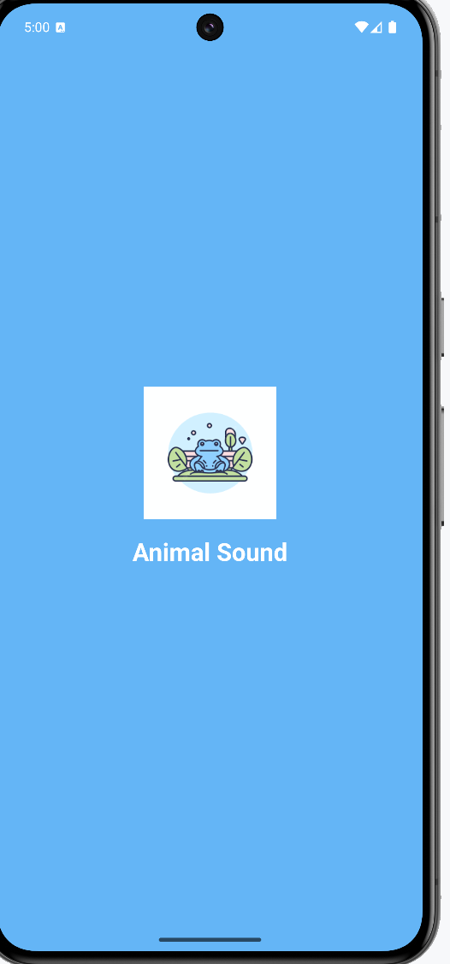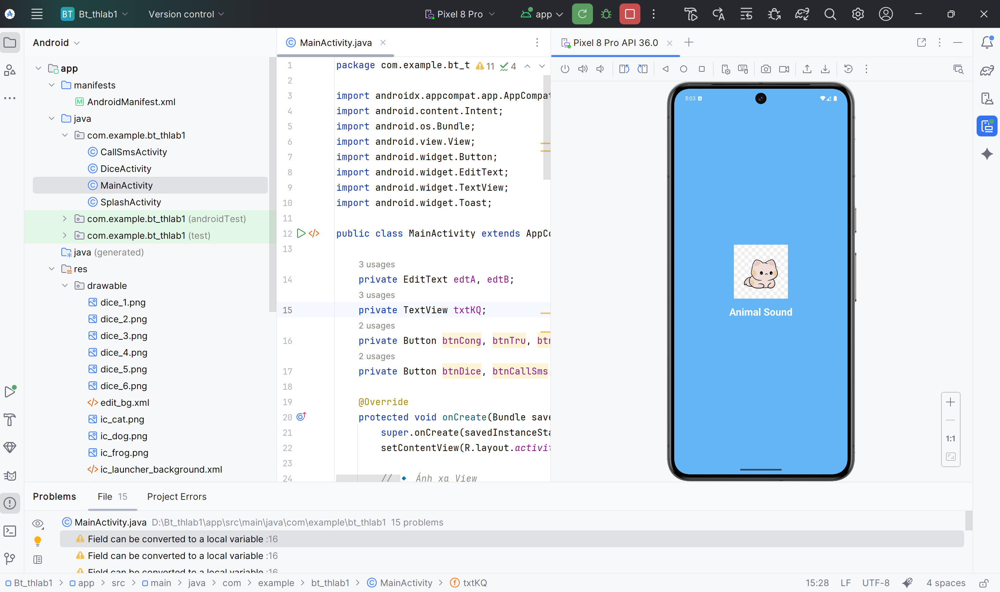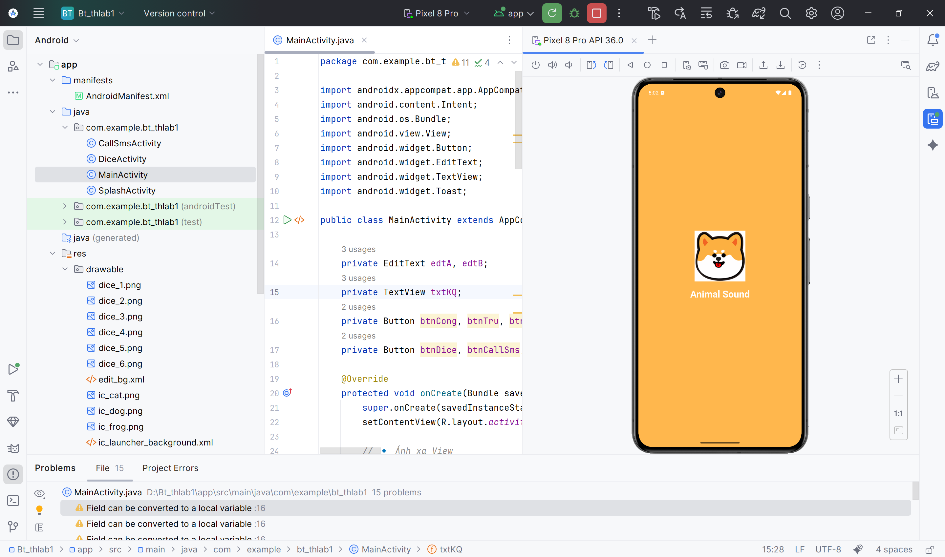

# BUỔI 2: BÀI TẬP THỰC HÀNH

## LAB_3

### BÀI TẬP_1

Tạo Project 🡪 mở app 🡪 New Project 🡪 Empty Views Activity 🡪 Next 🡪 đặt tên 🡪 finish

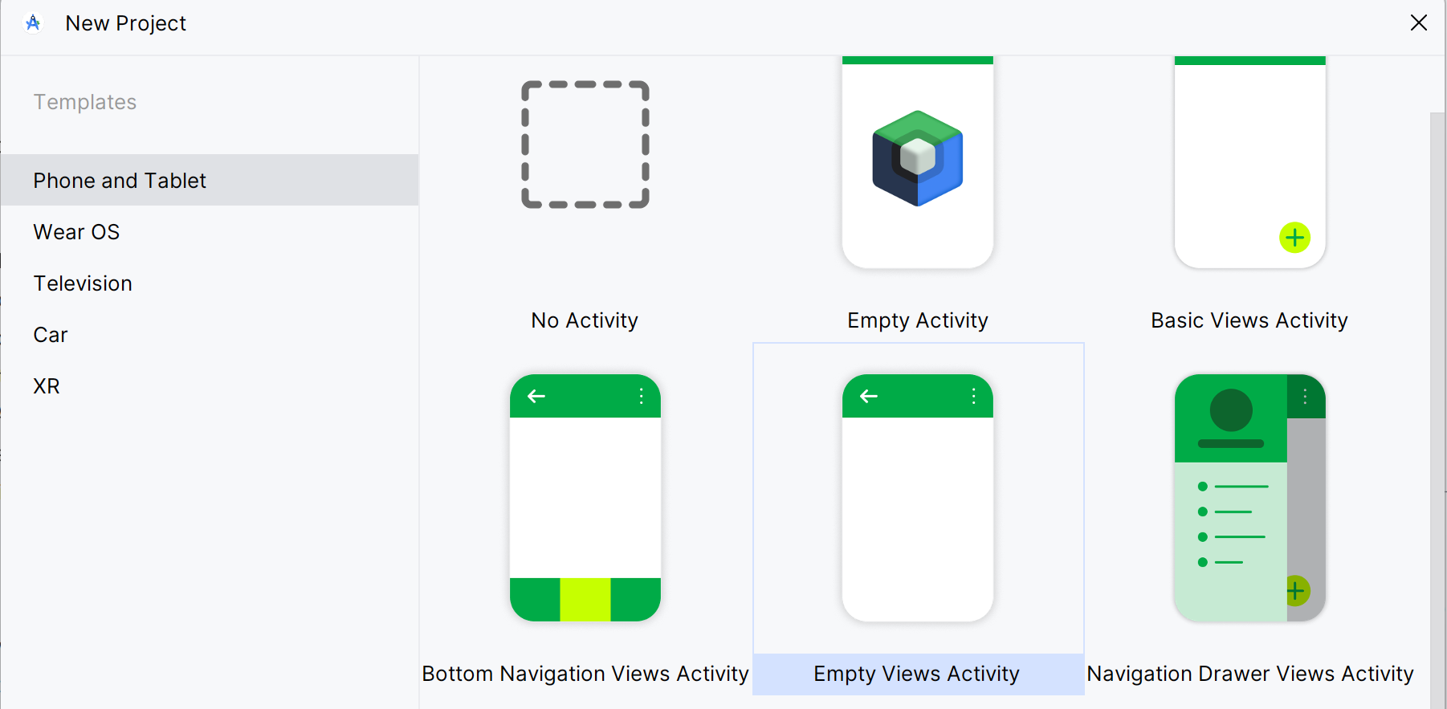

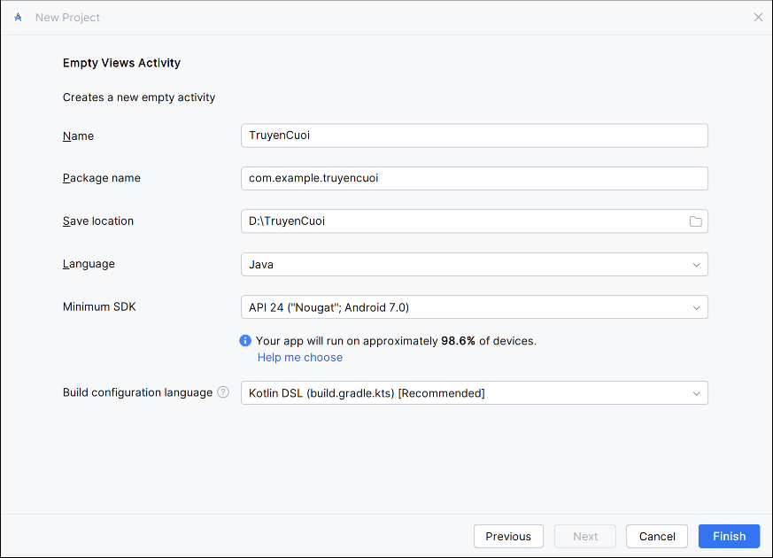

Drawable 🡪 tạo 3 file icon 🡪 đúp chuột phải 🡪 new 🡪 Vector Asset 🡪 Next

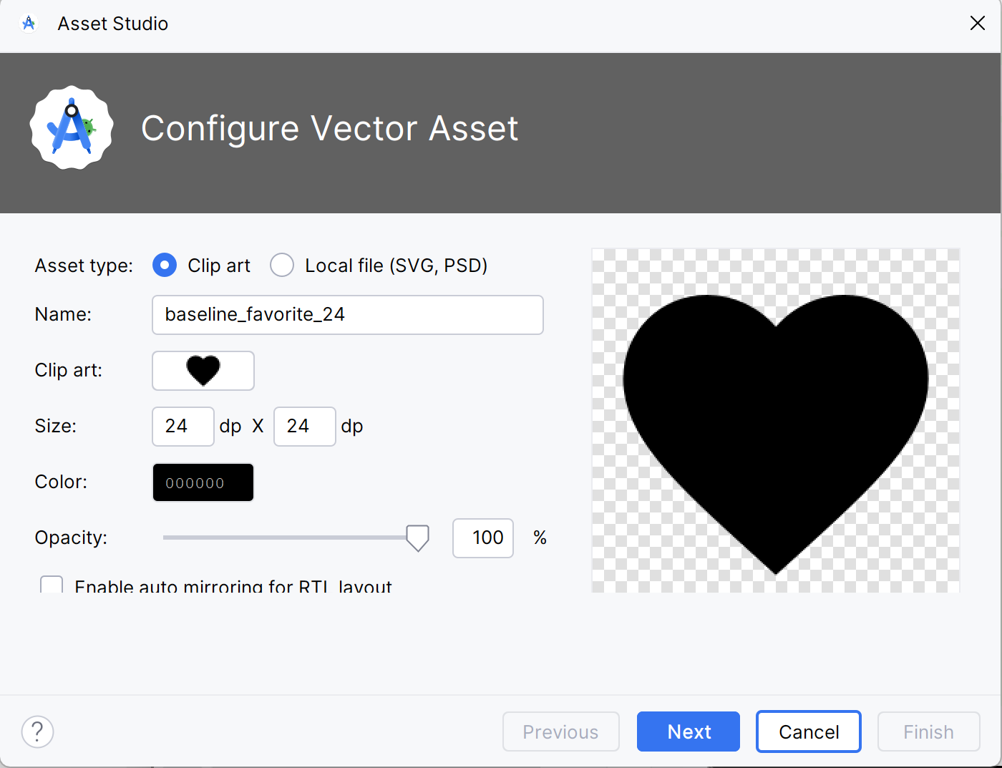

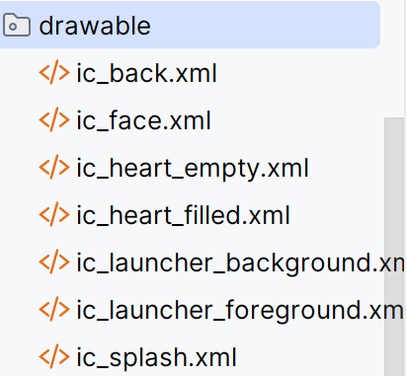

Ở layout 🡪 tạo từng file

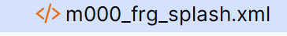

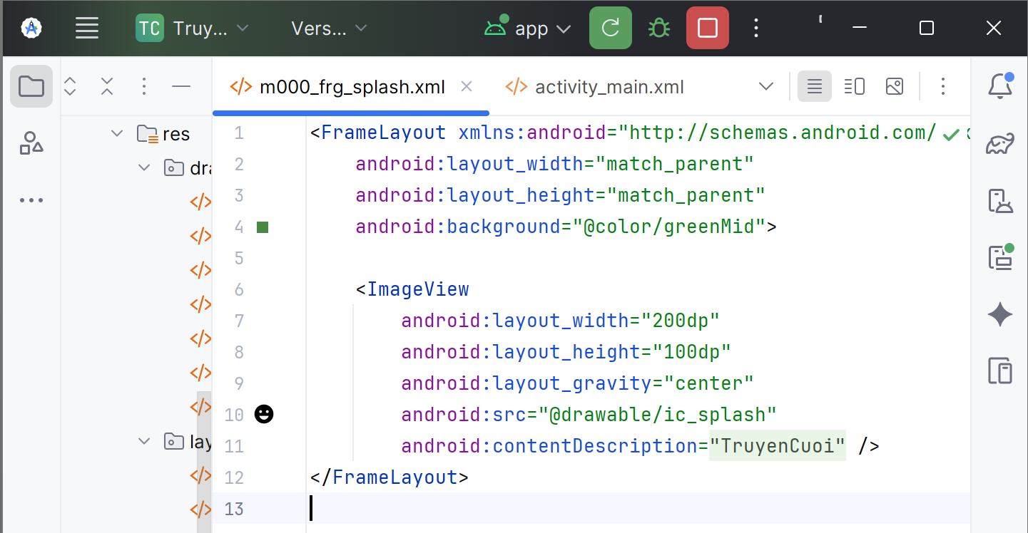

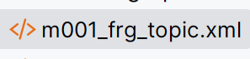

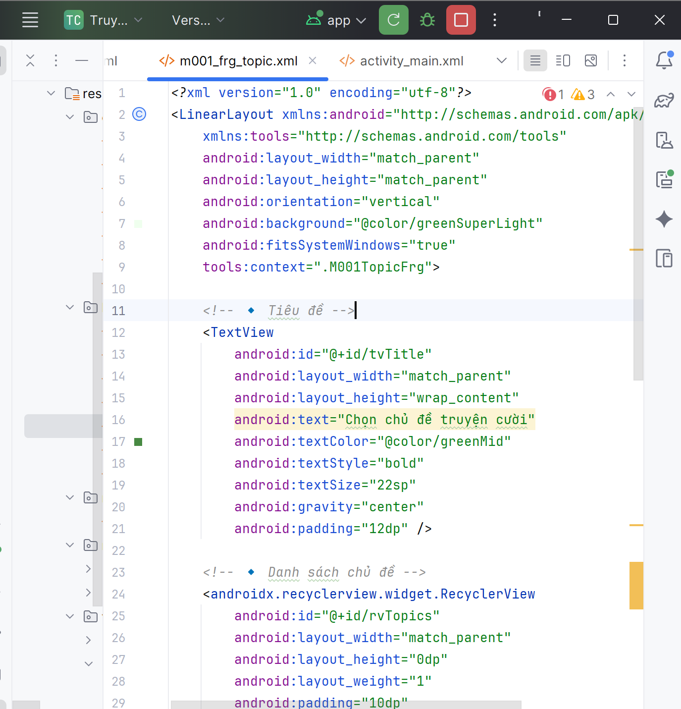

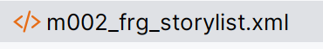

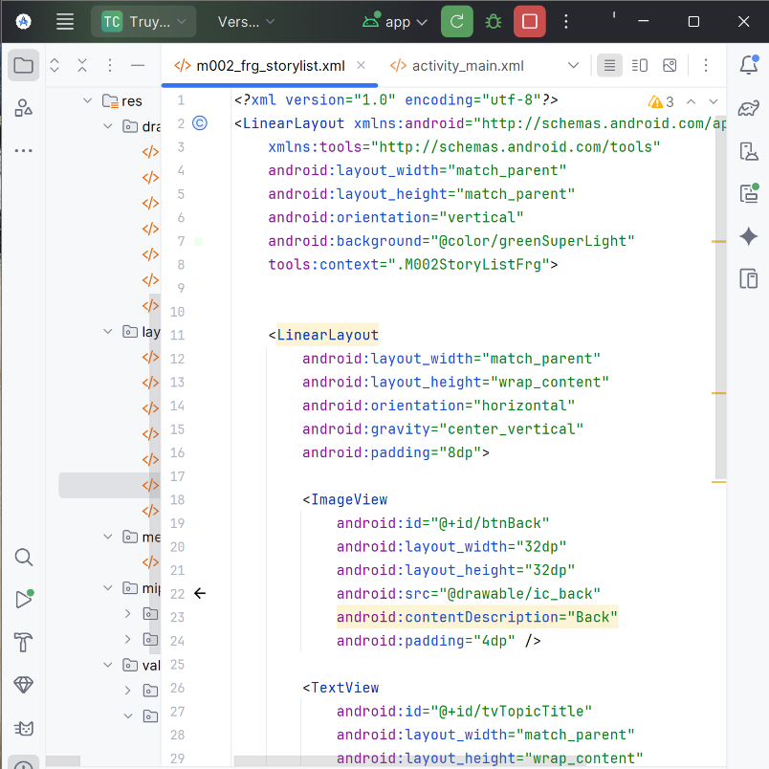

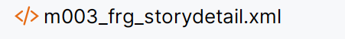

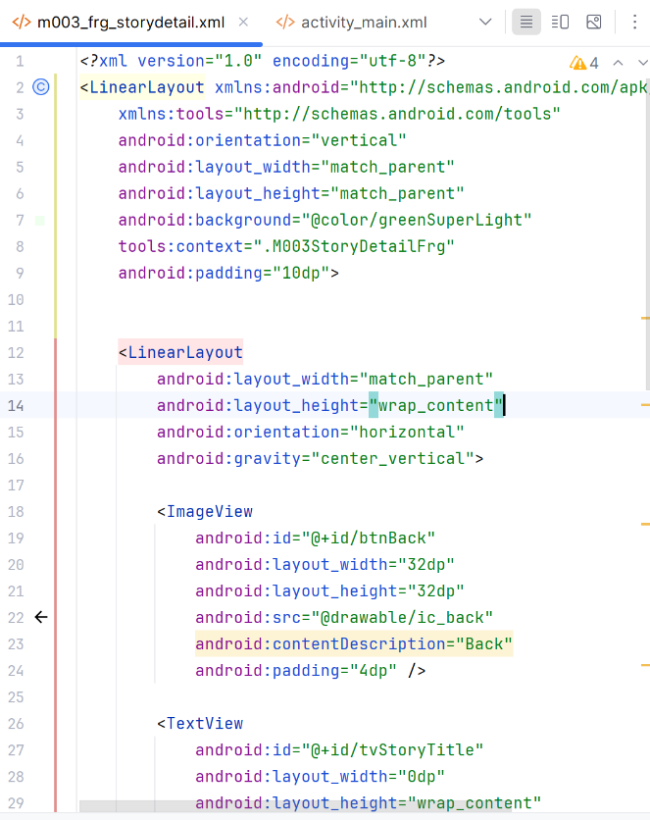

Tạo thêm file java

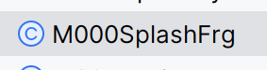

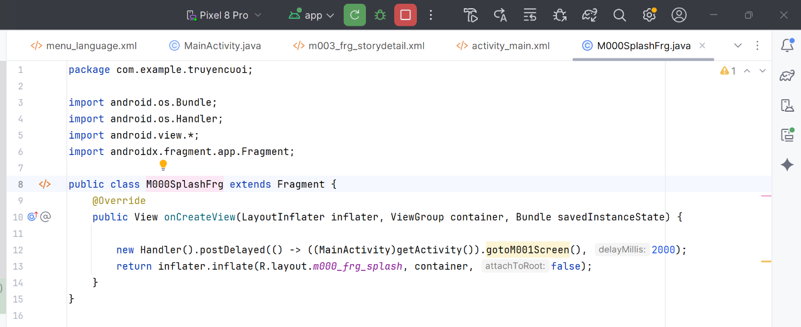

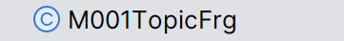

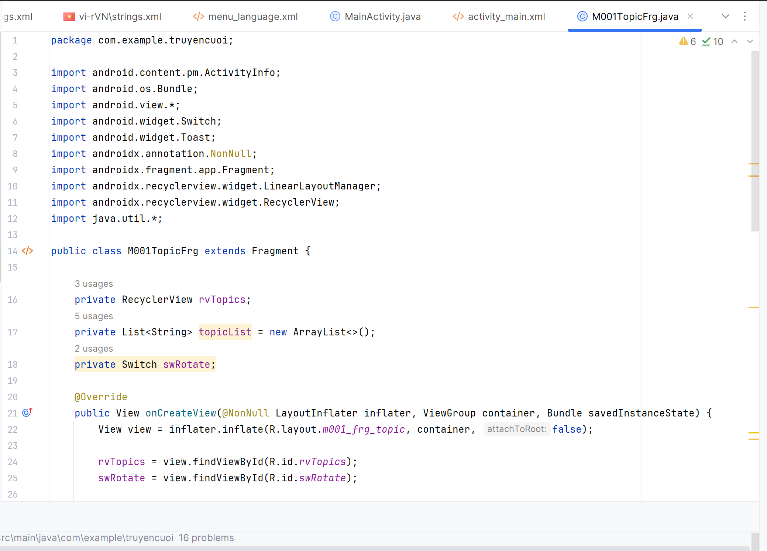

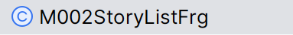

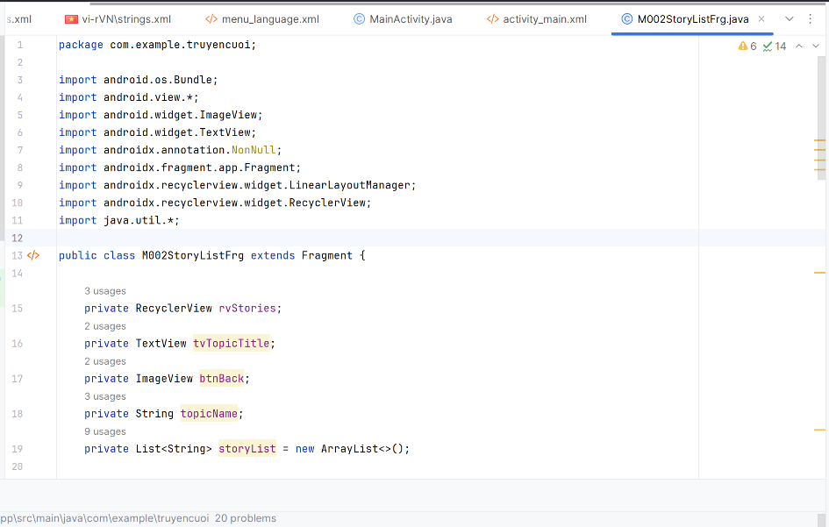

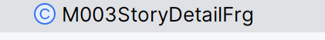

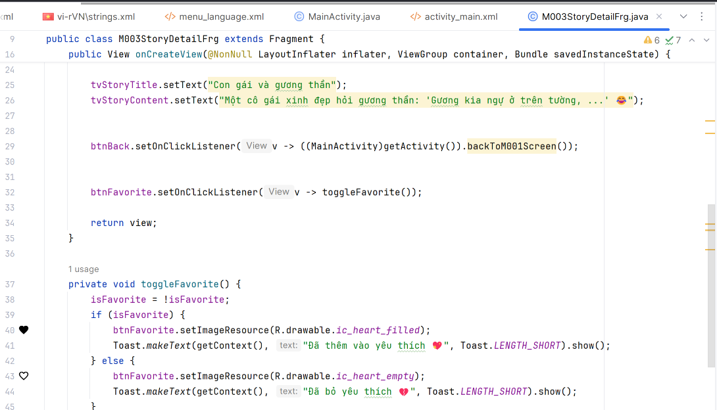

***Tạo file StoryAdapter***

package com.example.truyencuoi;

import android.view.*;

import android.widget.ImageView;

import android.widget.TextView;

import androidx.annotation.NonNull;

import androidx.recyclerview.widget.RecyclerView;

import java.util.List;

public class StoryAdapter extends RecyclerView.Adapter<StoryAdapter.StoryViewHolder> {

public interface OnStoryClickListener {

void onStoryClick(String storyTitle);

}

private final List<String> stories;

private final OnStoryClickListener listener;

public StoryAdapter(List<String> stories, OnStoryClickListener listener) {

this.stories = stories;

this.listener = listener;

}

@NonNull

@Override

public StoryViewHolder onCreateViewHolder(@NonNull ViewGroup parent, int viewType) {

View v = LayoutInflater.from(parent.getContext()).inflate(R.layout.item_story, parent, false);

return new StoryViewHolder(v);

}

@Override

public void onBindViewHolder(@NonNull StoryViewHolder holder, int position) {

String story = stories.get(position);

holder.tvStoryTitle.setText(story);

holder.itemView.setOnClickListener(v -> listener.onStoryClick(story));

}

@Override

public int getItemCount() {

return stories.size();

}

public static class StoryViewHolder extends RecyclerView.ViewHolder {

TextView tvStoryTitle;

ImageView imgStory;

public StoryViewHolder(@NonNull View itemView) {

super(itemView);

tvStoryTitle = itemView.findViewById(R.id.tvStoryTitle);

imgStory = itemView.findViewById(R.id.imgStory);

}

}

}

***Tạo file TopicAdapter***

package com.example.truyencuoi;

import android.view.*;

import android.widget.ImageView;

import android.widget.TextView;

import androidx.annotation.NonNull;

import androidx.recyclerview.widget.RecyclerView;

import java.util.List;

public class TopicAdapter extends RecyclerView.Adapter<TopicAdapter.TopicViewHolder> {

public interface OnTopicClickListener {

void onTopicClick(String topic);

}

private final List<String> topics;

private final OnTopicClickListener listener;

public TopicAdapter(List<String> topics, OnTopicClickListener listener) {

this.topics = topics;

this.listener = listener;

}

@NonNull

@Override

public TopicViewHolder onCreateViewHolder(@NonNull ViewGroup parent, int viewType) {

View v = LayoutInflater.from(parent.getContext()).inflate(R.layout.item_topic, parent, false);

return new TopicViewHolder(v);

}

@Override

public void onBindViewHolder(@NonNull TopicViewHolder holder, int position) {

String topic = topics.get(position);

holder.tvTopicName.setText(topic);

holder.itemView.setOnClickListener(v -> listener.onTopicClick(topic));

}

@Override

public int getItemCount() {

return topics.size();

}

public static class TopicViewHolder extends RecyclerView.ViewHolder {

TextView tvTopicName;

ImageView imgIcon;

public TopicViewHolder(@NonNull View itemView) {

super(itemView);

tvTopicName = itemView.findViewById(R.id.tvTopicName);

imgIcon = itemView.findViewById(R.id.imgIcon);

}

}

}

***Phần layout tạo thêm hai file***

* Item_story

<?xml version="1.0" encoding="utf-8"?>

<LinearLayout xmlns:android="http://schemas.android.com/apk/res/android"

android:layout_width="match_parent"

android:layout_height="wrap_content"

android:orientation="horizontal"

android:background="@color/white"

android:layout_marginVertical="6dp"

android:padding="12dp"

android:gravity="center_vertical">

<ImageView

android:id="@+id/imgStory"

android:layout_width="50dp"

android:layout_height="50dp"

android:src="@drawable/ic_face"

android:contentDescription="@string/app_name" />

<TextView

android:id="@+id/tvStoryTitle"

android:layout_width="match_parent"

android:layout_height="wrap_content"

android:text="Tên truyện"

android:textSize="18sp"

android:textColor="@color/black"

android:paddingStart="10dp" />

</LinearLayout>

* Item_topic

<?xml version="1.0" encoding="utf-8"?>

<LinearLayout xmlns:android="http://schemas.android.com/apk/res/android"

android:orientation="horizontal"

android:layout_width="match_parent"

android:layout_height="wrap_content"

android:padding="12dp"

android:layout_marginVertical="4dp"

android:background="@color/white">

<ImageView

android:id="@+id/imgIcon"

android:layout_width="40dp"

android:layout_height="40dp"

android:src="@drawable/ic_face"

android:contentDescription="@string/app_name" />

<TextView

android:id="@+id/tvTopicName"

android:layout_width="match_parent"

android:layout_height="wrap_content"

android:text="Truyện về con gái"

android:textColor="@color/black"

android:textSize="18sp"

android:paddingStart="10dp"

android:gravity="center_vertical" />

</LinearLayout>

Chạy run để ra kết quả :

* Giao diện mà hình chờ

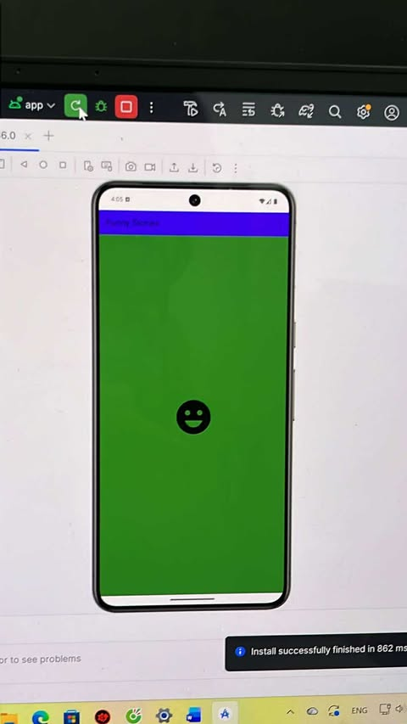

* Giao diện chọn chủ đề

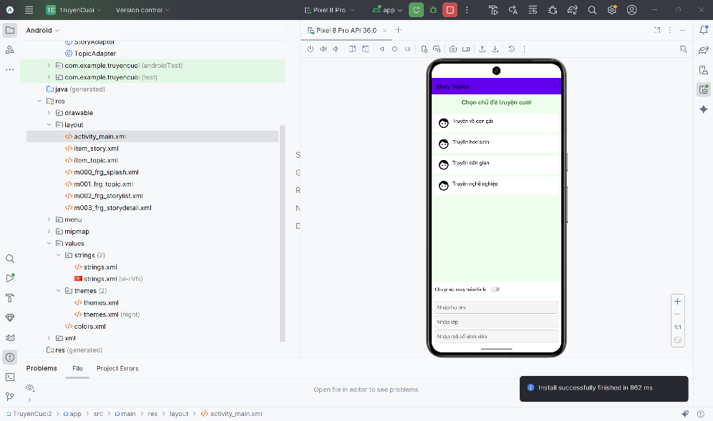

* Giao diện chọn truyện

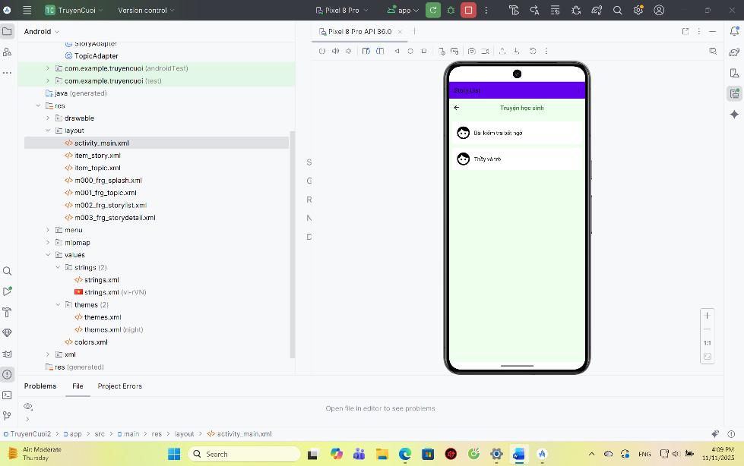

* Giao diện chi tiết câu chuyện

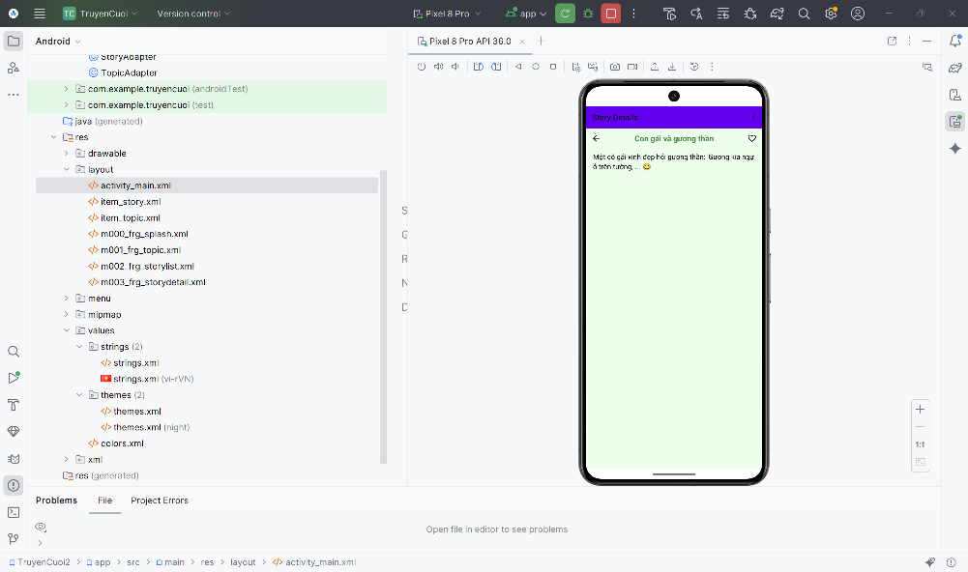

* Giao diện khi tắt chế độ quay

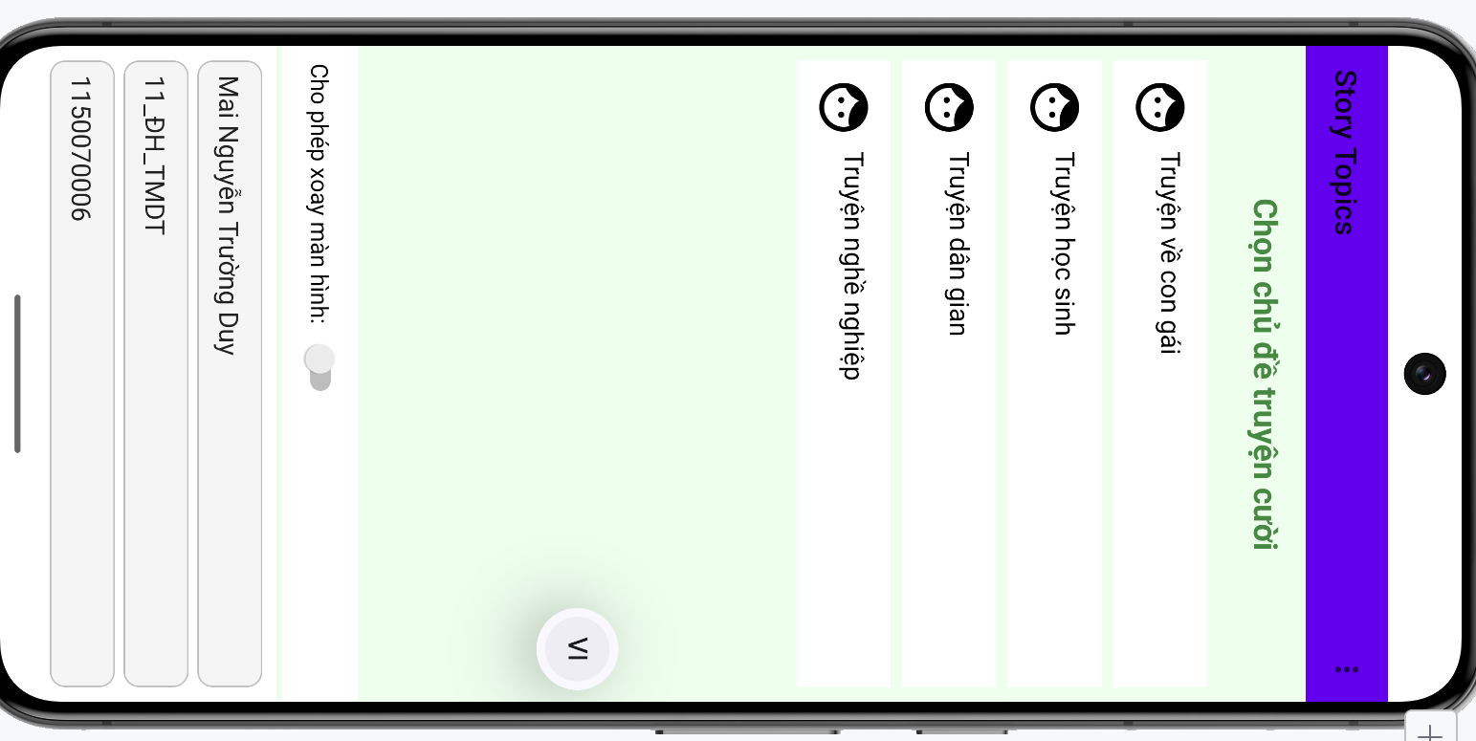

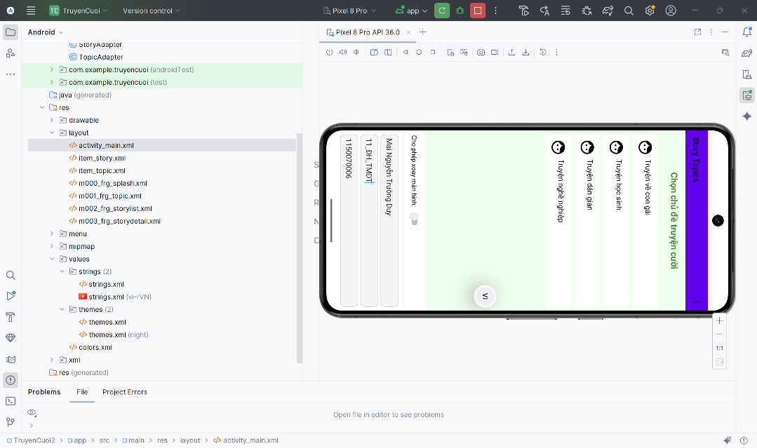

* Giao diện khi bật chế độ quay ngang

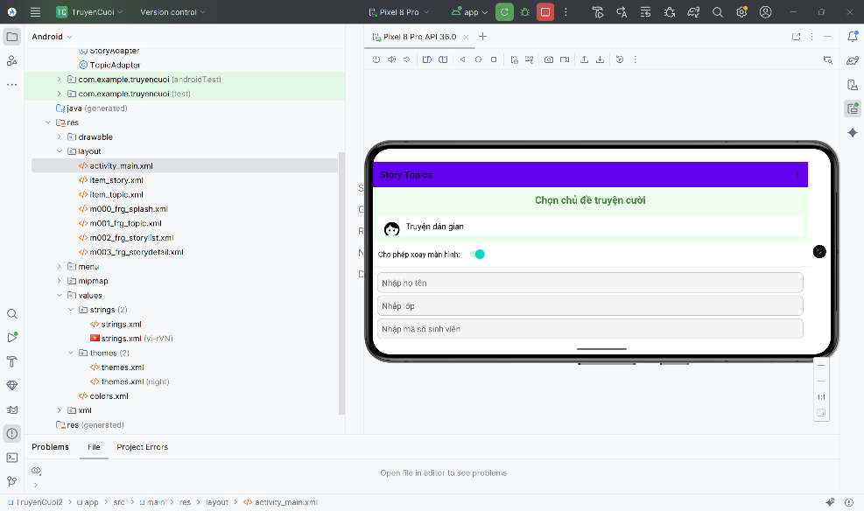

### BÀI TẬP_2

Mở thư mục res 🡪 chuột phải 🡪 New 🡪 Android Resource Directory

Đặt tên 🡪 ok 🡪 sẽ hai file string (một file string phiên bản tiếng việt và một file string bản Tiếng Anh)

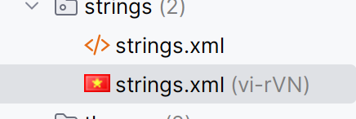

Strings.xml 🡪 chèn nội dung code bản tiếng anh vào

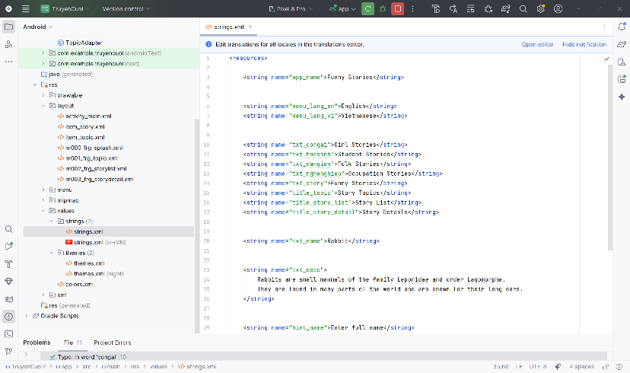

Strings.xml 🡪 chèn nội dung code bản tiếng việt

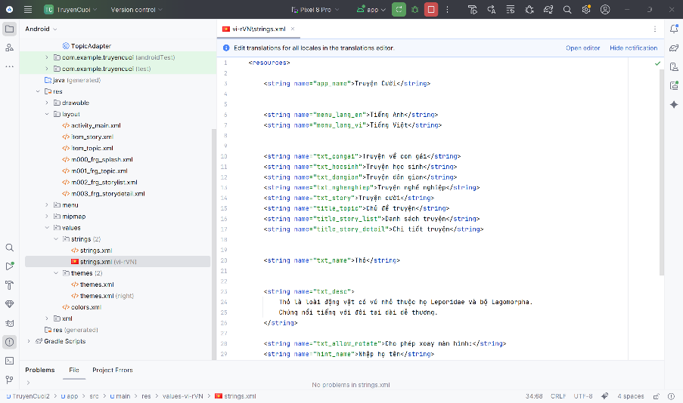

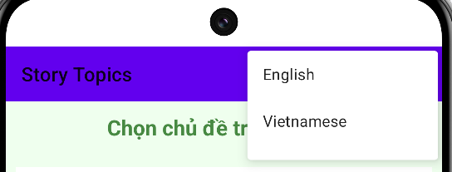

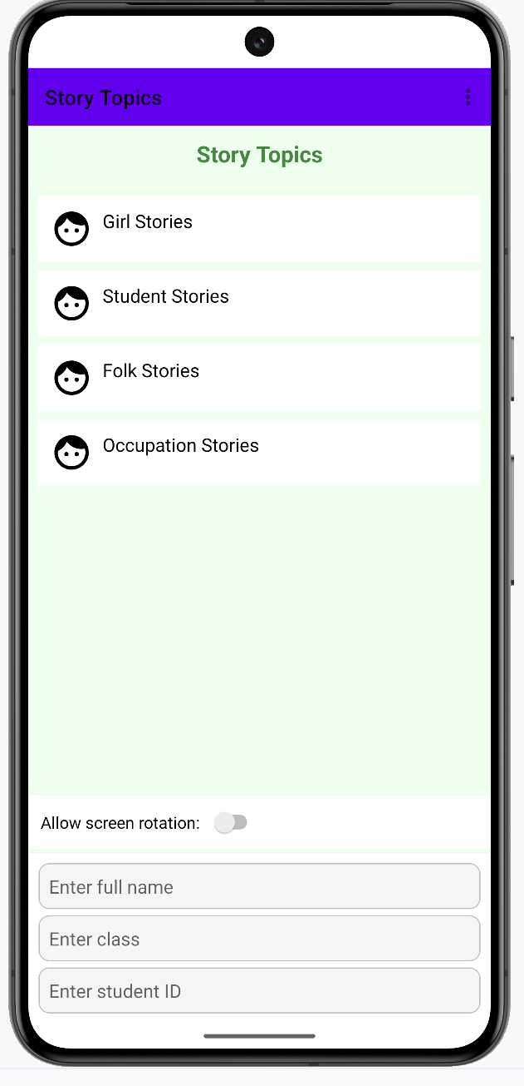

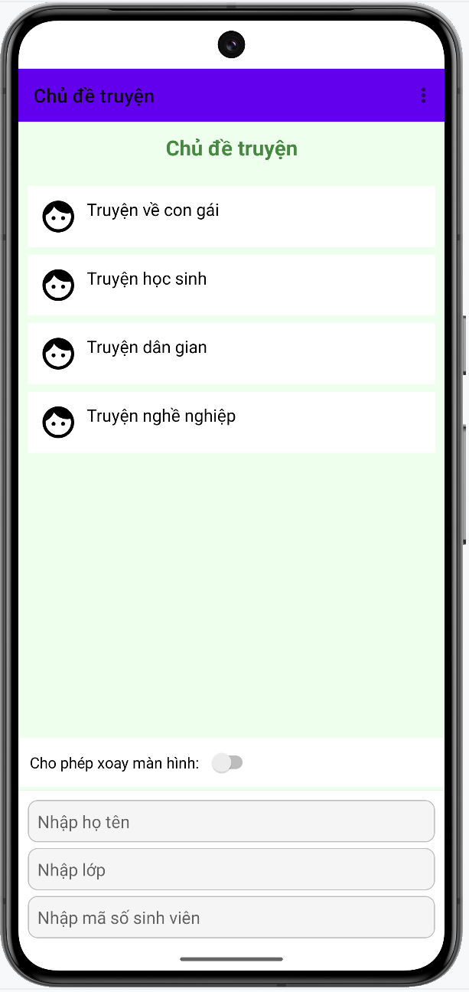

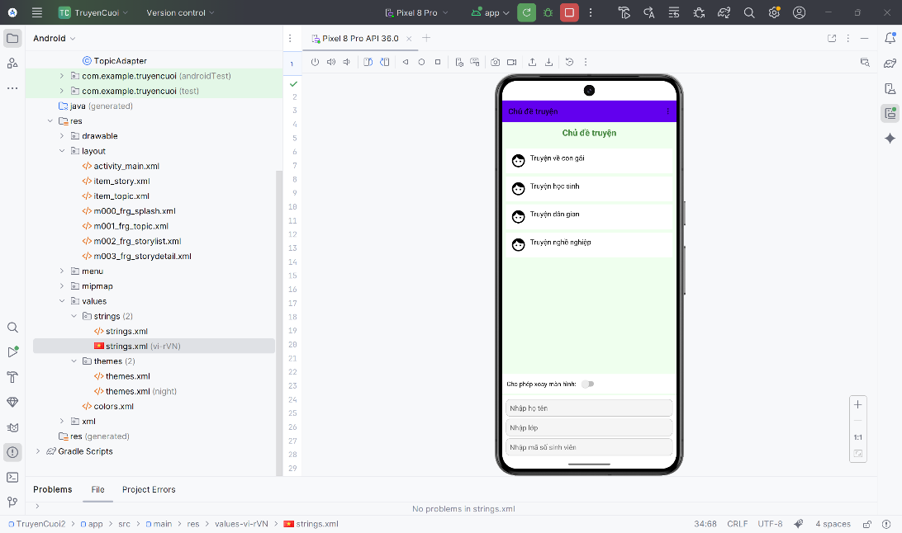

# BUỔI 3: BÀI TẬP THỰC HÀNH

## LAB_6

### LUYỆN TẬP

New Project 🡪 Views Activity 🡪 Next 🡪 đặt tên 🡪 finish

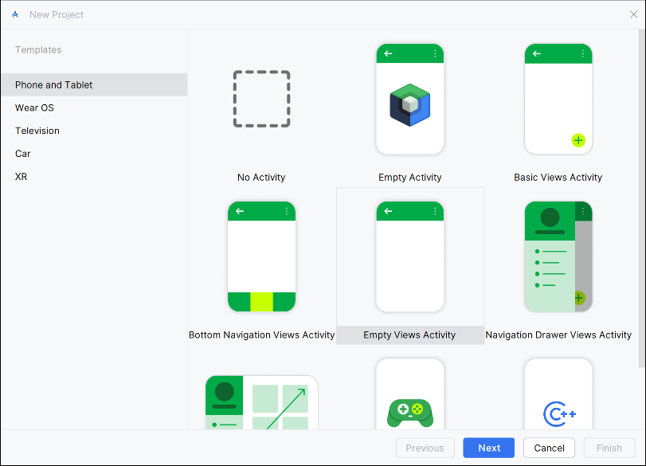

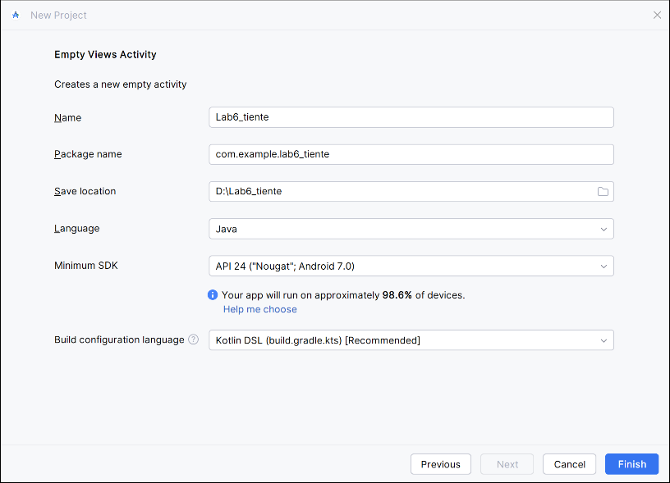

Tải file hình ảnh lá cờ của các quốc gia tiền tệ 🡪 tải và lưu với tên file flag_quốc gia.png 🡪 copy các file đó 🡪 kéo thả vào mục file drawable

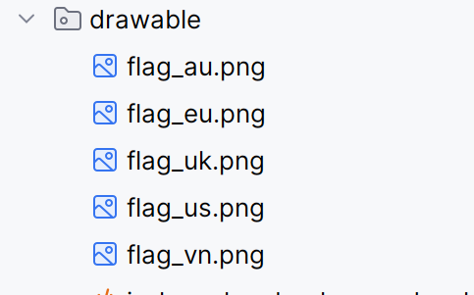

File values 🡪 strings.xml 🡪 dán nội dụng code vào 🡪 hiển thị danh sách các loại tiền tệ và mã quốc tế cho mỗi đơn vị tiền tệ.

|  |
| --- |
| <?xml version="1.0" encoding="utf-8"?>  <resources>  <string name="app_name">Chương trình đổi tiền</string>  <string name="author">Họ tên của bạn</string>  <string name="computer">Tên máy bạn đang dùng</string>  <string name="textbox_hint">Nhập số tiền</string>  <string name="usd_name">American Dollar</string>  <string name="eur_name">European Cash</string>  <string name="gbp_name">Great Britain</string>  <string name="aud_name">Australia Dollar</string>  <string name="vnd_name">Việt Nam Đồng</string>  <string name="usd_unit">USD</string>  <string name="eur_unit">EUR</string>  <string name="gbp_unit">GBP</string>  <string name="aud_unit">AUD</string>  <string name="vnd_unit">VND</string>  </resources> |

Tạo file CurrencyAdapter 🡪 chèn nội dung code vào 🡪 giúp ListView hiển thị danh sách kết quả đổi tiền 🡪 đảm nhận ba mảng dữ liệu: tên loại tiền, giá trị đã quy đổi và hình lá cờ. 🡪 nhờ adapter này, mỗi dòng trong ListView được hiển thị đầy đủ và đúng định dạng (hình + text), thay vì chỉ hiển thị chữ như ListView mặc định.

|  |
| --- |
| package com.example.lab6_tiente;  import android.content.Context;  import android.view.LayoutInflater;  import android.view.View;  import android.view.ViewGroup;  import android.widget.BaseAdapter;  import android.widget.ImageView;  import android.widget.TextView;  public class CurrencyAdapter extends BaseAdapter {  Context context;  String[] names;  double[] values;  int[] flags;  public CurrencyAdapter(Context context, String[] names, double[] values, int[] flags) {  this.context = context;  this.names = names;  this.values = values;  this.flags = flags;  }  @Override  public int getCount() {  return names.length;  }  @Override  public Object getItem(int i) {  return null;  }  @Override  public long getItemId(int i) {  return 0;  }  @Override  public View getView(int position, View convertView, ViewGroup parent) {  View view = LayoutInflater.from(context).inflate(R.layout.item_currency, parent, false);  ImageView img = view.findViewById(R.id.imgFlag);  TextView tvName = view.findViewById(R.id.tvName);  TextView tvValue = view.findViewById(R.id.tvValue);  img.setImageResource(flags[position]);  tvName.setText(names[position]);  tvValue.setText(String.valueOf(values[position]));  return view;  }  } |

MainActivity 🡪 điều khiển toàn bộ chương trình đổi tiền 🡪 thực hiện ba nhiệm vụ chính: nhận dữ liệu người dùng, tính toán theo tỷ giá và hiển thị kết quả lên ListView

|  |
| --- |
| package com.example.lab6_tiente;  import android.os.Bundle;  import android.widget.ArrayAdapter;  import android.widget.Button;  import android.widget.EditText;  import android.widget.ListView;  import android.widget.Spinner;  import androidx.appcompat.app.AppCompatActivity;  public class MainActivity extends AppCompatActivity {  EditText edtAmount;  Spinner spFrom;  Button btnConvert;  ListView lvResult;  String[] currencies = {"USD", "EUR", "GBP", "AUD", "VND"};  int[] flags = {  R.drawable.flag_us, // USD  R.drawable.flag_eu, // EUR  R.drawable.flag_uk, // GBP  R.drawable.flag_au, // AUD  R.drawable.flag_vn // VND  };  double[][] rate = {  {1, 0.80518, 0.6407, 0.82114, 21385.7}, // USD  {1.24172, 1, 0.79575, 1.51266, 26561.8}, // EUR  {1.56044, 1.25667, 1, 1.90091, 33374.9}, // GBP  {0.82114, 0.66119, 0.5262, 1, 17567.9}, // AUD  {0.00005, 0.00004, 0.00003, 0.00006, 1} // VND  };  @Override  protected void onCreate(Bundle savedInstanceState) {  super.onCreate(savedInstanceState);  // EdgeToEdge.enable(this);  setContentView(R.layout.activity_main);  edtAmount = findViewById(R.id.edtAmount);  spFrom = findViewById(R.id.spFrom);  btnConvert = findViewById(R.id.btnConvert);  lvResult = findViewById(R.id.lvResult);  ArrayAdapter<String> adapter = new ArrayAdapter<>(  this,  android.R.layout.simple_spinner_item,  currencies  );  adapter.setDropDownViewResource(android.R.layout.simple_spinner_dropdown_item);  spFrom.setAdapter(adapter);  btnConvert.setOnClickListener(v -> {  String inputStr = edtAmount.getText().toString().trim();  if (inputStr.isEmpty()) {  edtAmount.setError("Nhập số tiền");  return;  }  double input = Double.parseDouble(inputStr);  int pos = spFrom.getSelectedItemPosition();  double[] converted = new double[currencies.length];  for (int i = 0; i < currencies.length; i++) {  converted[i] = input * rate[pos][i];  }  CurrencyAdapter currencyAdapter =  new CurrencyAdapter(MainActivity.this, currencies, converted, flags);  lvResult.setAdapter(currencyAdapter);  });  }  } |

Activity_main.xml 🡪 dán nội ddung code vô

|  |
| --- |
| <?xml version="1.0" encoding="utf-8"?>  <LinearLayout xmlns:android="http://schemas.android.com/apk/res/android"  android:id="@+id/main"  android:orientation="vertical"  android:padding="16dp"  android:layout_width="match_parent"  android:layout_height="match_parent">  <EditText  android:id="@+id/edtAmount"  android:layout_width="match_parent"  android:layout_height="wrap_content"  android:hint="@string/textbox_hint"  android:inputType="numberDecimal"  android:layout_marginBottom="12dp"/>  <Spinner  android:id="@+id/spFrom"  android:layout_width="match_parent"  android:layout_height="wrap_content"  android:layout_marginBottom="12dp"/>  <Button  android:id="@+id/btnConvert"  android:layout_width="match_parent"  android:layout_height="wrap_content"  android:text="ĐỔI TIỀN" />  <ListView  android:id="@+id/lvResult"  android:layout_width="match_parent"  android:layout_height="wrap_content"  android:dividerHeight="1dp"  android:layout_marginTop="16dp"/>  </LinearLayout> |

Tạo thêm file 🡪item_currency.xml

|  |
| --- |
| <?xml version="1.0" encoding="utf-8"?>  <LinearLayout xmlns:android="http://schemas.android.com/apk/res/android"  android:orientation="horizontal"  android:padding="8dp"  android:gravity="center_vertical"  android:layout_width="match_parent"  android:layout_height="wrap_content">  <ImageView  android:id="@+id/imgFlag"  android:layout_width="40dp"  android:layout_height="25dp"  android:layout_marginRight="10dp"/>  <TextView  android:id="@+id/tvName"  android:layout_width="60dp"  android:layout_height="wrap_content"  android:textSize="16sp"/>  <TextView  android:id="@+id/tvValue"  android:layout_width="wrap_content"  android:layout_height="wrap_content"  android:textSize="16sp"  android:layout_marginLeft="20dp"/>  </LinearLayout> |

Run chạy ra kết quả :

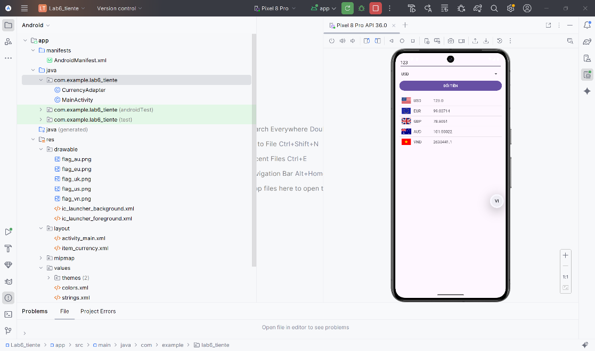

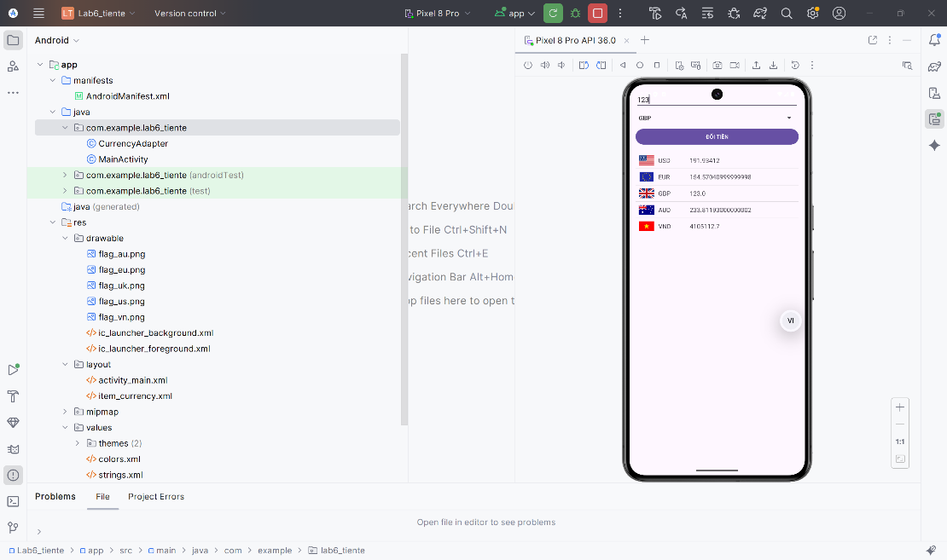

* Bài Tập: Bảng tỉ lệ giữa các đơn vị độ dài

Tạo file LengthActivity.java 🡪 màn hình thực hiện chức năng đổi đơn vị đo chiều dài theo bảng tỉ lệ 🡪 Ứng dụng gồm một ô nhập số, một Spinner chọn loại đơn vị gốc và một ListView để hiển thị kết quả quy đổi sang các đơn vị còn lại.

|  |
| --- |
| package com.example.lab6_tiente;  import android.os.Bundle;  import android.widget.*;  import androidx.appcompat.app.AppCompatActivity;  public class LengthActivity extends AppCompatActivity {  EditText edtInput;  Spinner spUnit;  ListView lvResult;  String[] units = {"Hải lý", "Dặm", "Km", "Lý", "Met", "Yard", "Foot", "Inch"};  double[][] rate = {  {1, 1.15077945, 1.852000, 20.2537183, 1852, 2025.37183, 6076.11549, 72913.38583},  {0.86897642, 1, 1.609344, 17.6000000, 1609.344, 1760, 5280, 63360},  {0.53995680, 0.62137119, 1, 10.9361330, 1000, 1093.61330, 3280.83990, 39370.07874},  {0.04937365, 0.05681818, 0.091440, 1, 91.440, 100, 300, 3600},  {0.00053996, 0.00062137, 0.001000, 0.01093613, 1, 1.093613, 3.28084, 39.37008},  {0.00049374, 0.00056818, 0.0009144, 0.01, 0.9144, 1, 3, 36},  {0.00016458, 0.00018939, 0.0003048, 0.00333333, 0.3048, 0.333333, 1, 12},  {0.00001371, 0.00001578, 0.0000254, 0.00027778, 0.0254, 0.0277778, 0.083333, 1}  };  @Override  protected void onCreate(Bundle savedInstanceState) {  super.onCreate(savedInstanceState);  setContentView(R.layout.activity_length);  edtInput = findViewById(R.id.edtInput);  spUnit = findViewById(R.id.spUnit);  lvResult = findViewById(R.id.lvResult);  ArrayAdapter<String> adapter = new ArrayAdapter<>(  this, android.R.layout.simple_spinner_item, units);  adapter.setDropDownViewResource(android.R.layout.simple_spinner_dropdown_item);  spUnit.setAdapter(adapter);  edtInput.addTextChangedListener(new android.text.TextWatcher() {  @Override public void beforeTextChanged(CharSequence s, int start, int count, int after) {}  @Override public void onTextChanged(CharSequence s, int start, int before, int count) {  convert();  }  @Override public void afterTextChanged(android.text.Editable s) {}  });  spUnit.setOnItemSelectedListener(new AdapterView.OnItemSelectedListener() {  @Override  public void onItemSelected(AdapterView<?> parent, android.view.View view, int position, long id) {  convert();  }  @Override  public void onNothingSelected(AdapterView<?> parent) {}  });  }  void convert() {  String s = edtInput.getText().toString().trim();  if (s.isEmpty()) return;  double input = Double.parseDouble(s);  int pos = spUnit.getSelectedItemPosition();  double[] result = new double[units.length];  for (int i = 0; i < units.length; i++)  result[i] = input * rate[pos][i];  LengthAdapter adapter = new LengthAdapter(  LengthActivity.this, units, result);  lvResult.setAdapter(adapter);  }  } |

Tạo file LengthAdapter.java 🡪 tùy chỉnh dùng để hiển thị danh sách các giá trị chiều dài đã được quy đổi 🡪 Adapter nhận vào 2 mảng: danh sách tên đơn vị và danh sách giá trị đã tính ra từ hàm convert() .

|  |
| --- |
| package com.example.lab6_tiente;  import android.content.Context;  import android.view.*;  import android.widget.BaseAdapter;  import android.widget.TextView;  public class LengthAdapter extends BaseAdapter {  Context context;  String[] units;  double[] values;  public LengthAdapter(Context context, String[] units, double[] values) {  this.context = context;  this.units = units;  this.values = values;  }  @Override  public int getCount() {  return units.length;  }  @Override  public Object getItem(int i) { return null; }  @Override  public long getItemId(int i) { return 0; }  @Override  public View getView(int position, View convertView, ViewGroup parent) {  View view = LayoutInflater.from(context)  .inflate(R.layout.item_length, parent, false);  TextView tvValue = view.findViewById(R.id.tvValue);  TextView tvUnit = view.findViewById(R.id.tvUnit);  tvValue.setText(String.format("%.4f", values[position]));  tvUnit.setText(units[position]);  return view;  }  } |

Tạo file activity_length.xml 🡪 dán nội dung code vào

|  |
| --- |
| <?xml version="1.0" encoding="utf-8"?>  <LinearLayout xmlns:android="http://schemas.android.com/apk/res/android"  android:orientation="vertical"  android:padding="16dp"  android:paddingTop="40dp"  android:layout_width="match_parent"  android:layout_height="match_parent">  <EditText  android:id="@+id/edtInput"  android:layout_width="match_parent"  android:layout_height="wrap_content"  android:hint="1.23"  android:inputType="numberDecimal"  android:focusable="true"  android:focusableInTouchMode="true"  android:clickable="true"  android:layout_marginBottom="8dp"/>  <Spinner  android:id="@+id/spUnit"  android:layout_width="match_parent"  android:layout_height="wrap_content"/>  <TextView  android:layout_width="match_parent"  android:layout_height="wrap_content"  android:text="Tương đương với"  android:textStyle="bold"  android:textSize="18sp"  android:paddingTop="20dp"  android:paddingBottom="10dp"/>  <ListView  android:id="@+id/lvResult"  android:layout_width="match_parent"  android:layout_height="0dp"  android:layout_weight="1" />  </LinearLayout> |

Tạo file item_length.xml 🡪 dán nội dung code vào

|  |
| --- |
| <?xml version="1.0" encoding="utf-8"?>  <LinearLayout xmlns:android="http://schemas.android.com/apk/res/android"  android:orientation="horizontal"  android:padding="10dp"  android:layout_width="match_parent"  android:layout_height="wrap_content">  <TextView  android:id="@+id/tvValue"  android:layout_width="0dp"  android:layout_height="wrap_content"  android:layout_weight="1"  android:textSize="17sp"  android:textColor="#000"/>  <TextView  android:id="@+id/tvUnit"  android:layout_width="wrap_content"  android:layout_height="wrap_content"  android:textSize="17sp"  android:textColor="#000"/>  </LinearLayout> |

Run chạy ra kết quả:

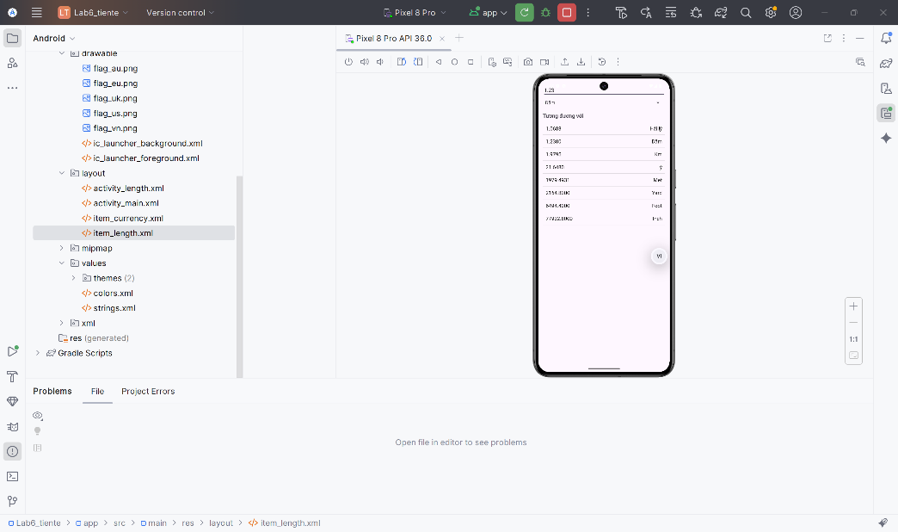

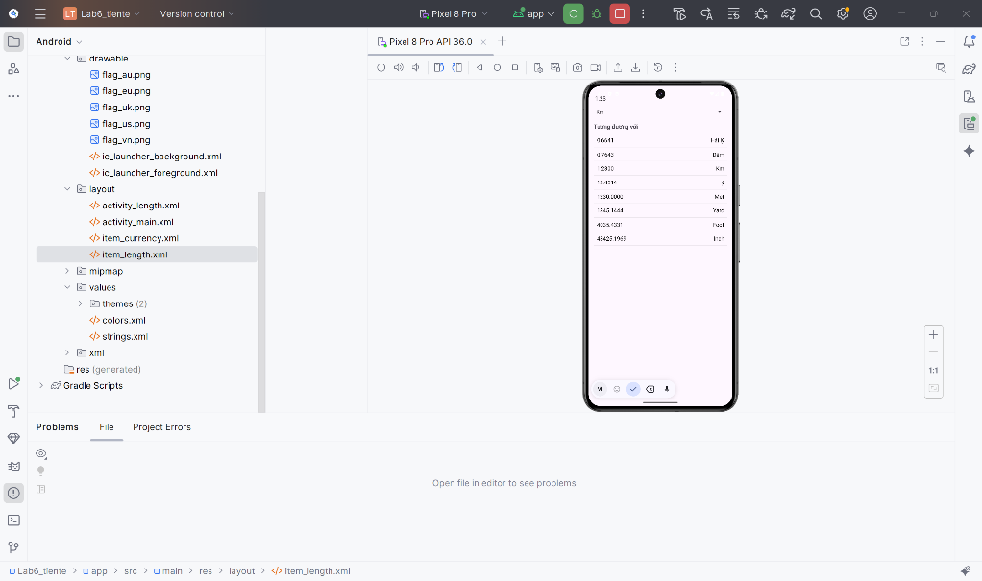

## LAB_7

### BÀI TẬP_1

Tạo file CustomButtonActivity.java 🡪 dán nội dung

|  |
| --- |
| package com.example.lab6_tiente;  import android.os.Bundle;  import androidx.appcompat.app.AppCompatActivity;  public class CustomButtonActivity extends AppCompatActivity {  @Override  protected void onCreate(Bundle savedInstanceState) {  super.onCreate(savedInstanceState);  setContentView(R.layout.activity_custom_button);  }  } |

Tiếp theo file activity_custom_button.xml

|  |
| --- |
| <?xml version="1.0" encoding="utf-8"?>  <ScrollView xmlns:android="http://schemas.android.com/apk/res/android"  android:layout_width="match_parent"  android:layout_height="match_parent"  android:padding="16dp">  <LinearLayout  android:layout_width="match_parent"  android:layout_height="wrap_content"  android:orientation="vertical"  android:paddingTop="50dp">  <TextView  android:text="Custom Button"  android:textSize="20sp"  android:textStyle="bold"  android:textColor="#B71C1C"  android:gravity="center"  android:layout_width="match_parent"  android:layout_height="wrap_content"/>  <LinearLayout  android:orientation="horizontal"  android:layout_marginTop="20dp"  android:layout_width="match_parent"  android:layout_height="wrap_content">  <LinearLayout  android:orientation="vertical"  android:layout_width="0dp"  android:layout_weight="1"  android:layout_height="wrap_content">  <TextView  android:text="Selectors"  android:textStyle="bold"  android:textSize="16sp"  android:layout_width="wrap_content"  android:layout_height="wrap_content"/>  <Button  android:text="COLORED SELECTOR"  android:background="@drawable/shape_colored_selector"  android:layout_marginTop="10dp"  android:layout_width="wrap_content"  android:layout_height="wrap_content"/>  <Button  android:text="COLOR SELECTOR DISABLED"  android:background="@drawable/shape_colored_disabled"  android:enabled="false"  android:layout_marginTop="10dp"  android:layout_width="wrap_content"  android:layout_height="wrap_content"/>  <ImageView  android:src="@drawable/emoji1"  android:layout_marginTop="20dp"  android:layout_width="80dp"  android:layout_height="80dp"/>  </LinearLayout>  <LinearLayout  android:orientation="vertical"  android:layout_width="0dp"  android:layout_weight="1"  android:layout_height="wrap_content">  <TextView  android:text="Shapes+Selectors"  android:textStyle="bold"  android:textSize="16sp"  android:layout_width="wrap_content"  android:layout_height="wrap_content"/>  <Button  android:text="ROUND SHAPE"  android:background="@drawable/shape_round"  android:layout_marginTop="10dp"  android:layout_width="wrap_content"  android:layout_height="wrap_content"/>  <Button  android:text="SHAPE WITH GRADIENT"  android:textColor="#000"  android:background="@drawable/shape_gradient"  android:layout_marginTop="10dp"  android:layout_width="wrap_content"  android:layout_height="wrap_content"/>  <Button  android:text="SELECTOR SHAPE"  android:background="@drawable/shape_selector_shape"  android:layout_marginTop="10dp"  android:layout_width="wrap_content"  android:layout_height="wrap_content"/>  <ImageView  android:src="@drawable/emoji2"  android:layout_marginTop="20dp"  android:layout_width="80dp"  android:layout_height="80dp"/>  </LinearLayout>  </LinearLayout>  </LinearLayout>  </ScrollView> |

Tải hai ảnh emoji 🡪 cho vào file drawable

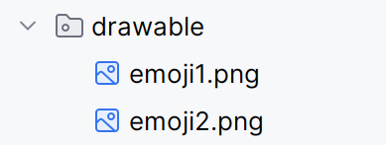

Tiếp tục ở drawable 🡪 tạo thêm các file hình

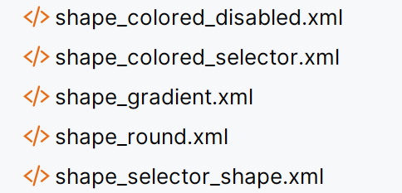

Để áp dụng đổi được màu mình chọn themes 🡪 đổi

<resources xmlns:tools="http://schemas.android.com/tools">

<!-- Base application theme. -->

<stylename="Base.Theme.Lab6_tiente"parent="Theme.AppCompat.DayNight.NoActionBar">

<!-- Customize your light theme here. -->

<!-- <item name="colorPrimary">@color/my_light_primary</item> -->

</style>

<style name="Theme.Lab6_tiente" parent="Base.Theme.Lab6_tiente" />

</resources>

Run 🡪 chạy ra kết quả

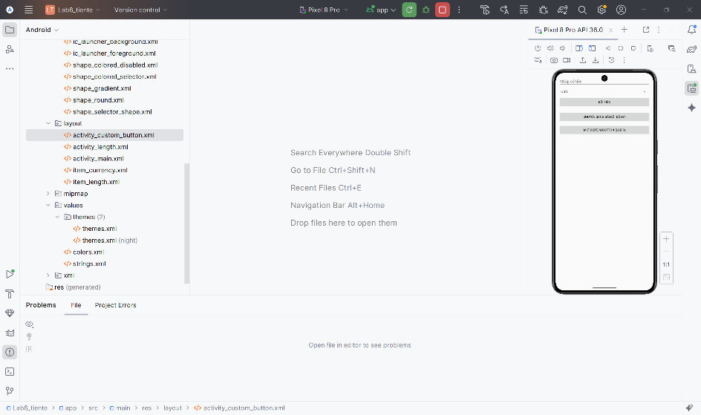

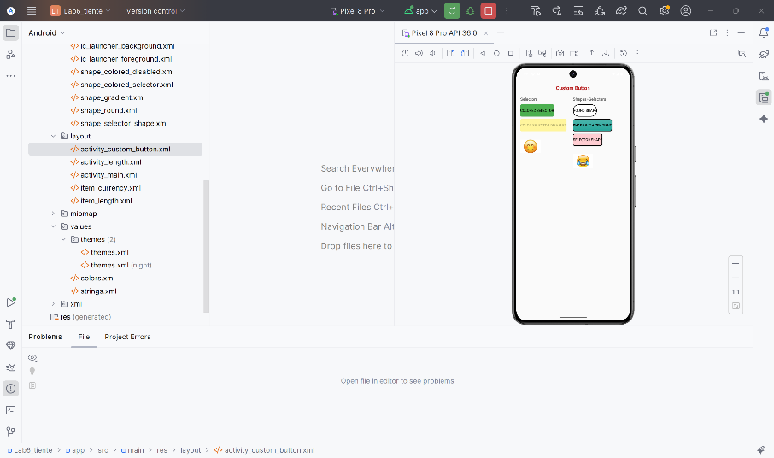

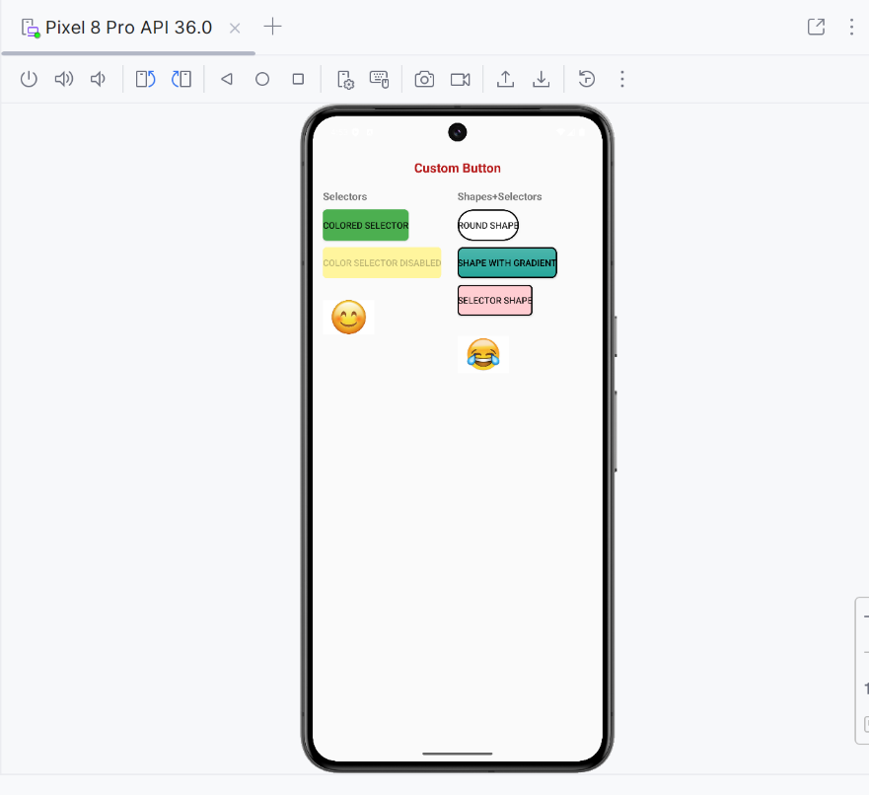

# BUỔI 4: BÀI TẬP THỰC HÀNH

## LAB_10_11

### LUYỆN TẬP

Tạo new project 🡪 chọn loại Empty View Activity 🡪 đặt tên file 🡪 finish

Sau khi tạo file xong 🡪 mục values 🡪 chọn colors.xml 🡪 thêm màu mình muốn

<resources>  
 <colorname="black">#FF000000</color>  
 <colorname="white">#FFFFFFFF</color>  
 <colorname="mainPrimary">#FF6F61</color>  
 <colorname="mainLight">#FF8F7F</color>  
 <colorname="mainBg">#FFF4F2</color>  
  
 <colorname="textDark">#333333</color>  
  
</resources>

Cũng values 🡪 themes 🡪 đổi sang chế độ

<stylename="Base.Theme.LAB10_11" parent="Theme.MaterialComponents.DayNight.NoActionBar">

Mình sẽ tạo thư mục chứa ảnh trong assets

Trong Android Studio, trong app/src/main:

* Nếu chưa có thư mục assets → chuột phải main → New → Folder → Assets Folder → OK.

Trong assets, tạo tiếp thư mục: photo

* Chuột phải assets → New → Directory → đặt tên photo.

Tải mấy ảnh chủ đề về máy lúc với đuôi tên file .png 🡪 cho vào thư mục

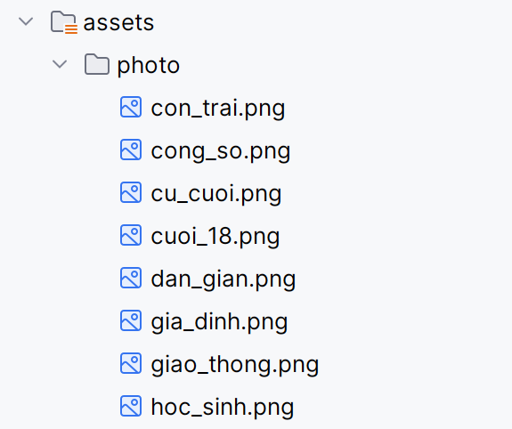

Ở thư mục Java 🡪 mình tạo file 🡪 M000SlashpFrg.Java🡪 chèn nội dung code vào

packagecom.example.lab10_11;  
  
importandroid.os.Bundle;  
importandroid.os.Handler;  
importandroid.view.LayoutInflater;  
importandroid.view.View;  
importandroid.view.ViewGroup;  
  
importandroidx.fragment.app.Fragment;  
  
public class M000SplashFrg extends Fragment {  
  
 @Override  
 public View onCreateView(LayoutInflater inflater, ViewGroup container, Bundle savedInstanceState) {  
 View view = inflater.inflate(R.layout.*m000_frg_splash*, container, false);  
 new Handler().postDelayed(() -> {  
 ((MainActivity)getActivity()).gotoM001Screen();  
 },2000);  
 return view;  
 }  
}

file kế tiếp M001TopicFrg.Java 🡪 dán nội dung code vào

package com.example.lab10_11;  
  
import android.content.Context;  
import android.graphics.BitmapFactory;  
import android.os.Bundle;  
import android.view.LayoutInflater;  
import android.view.View;  
import android.view.ViewGroup;  
import android.widget.ImageView;  
import android.widget.LinearLayout;  
import android.widget.TextView;  
  
import androidx.fragment.app.Fragment;  
  
import java.io.IOException;  
  
public class M001TopicFrg extends Fragment implements View.OnClickListener {  
  
 private Context mContext;  
  
 @Override  
 public void onAttach(Context context) {  
 super.onAttach(context);  
 mContext = context;  
 }  
  
 @Override  
 public View onCreateView(LayoutInflater inflater, ViewGroup container,  
 Bundle savedInstanceState) {  
  
 View rootView = inflater.inflate(R.layout.*m001_frg_topic*, container, false);  
 initViews(rootView);  
 return rootView;  
 }  
  
 private void initViews(View v) {  
 LinearLayout lnMain = v.findViewById(R.id.*ln_topic*);  
 lnMain.removeAllViews();  
  
 try {  
   
 String[] listItem = mContext.getAssets().list("photo");  
 if (listItem == null) return;  
  
 for (String fileName : listItem) {  
   
 String name = fileName.substring(0, fileName.lastIndexOf("."));  
  
 View vTopic = LayoutInflater.*from*(mContext)  
 .inflate(R.layout.*item_topic*, lnMain, false);  
  
 ImageView ivTopic = vTopic.findViewById(R.id.*iv_topic*);  
 TextView tvTopic = vTopic.findViewById(R.id.*tv_topic*);  
  
   
 ivTopic.setImageBitmap(  
 BitmapFactory.*decodeStream*(  
 mContext.getAssets().open("photo/" + fileName)  
 )  
 );  
  
   
 tvTopic.setText(name.replace("_", " "));  
  
   
 lnMain.addView(vTopic);  
  
   
 LinearLayout.LayoutParams params =  
 (LinearLayout.LayoutParams) vTopic.getLayoutParams();  
 params.bottomMargin = 30;  
 vTopic.setLayoutParams(params);  
  
   
 vTopic.setTag(name);   
 vTopic.setOnClickListener(this);  
 }  
  
 } catch (IOException e) {  
 e.printStackTrace();  
 }  
 }  
  
 @Override  
 public void onClick(View v) {  
 String topicName = (String) v.getTag();  
   
 ((MainActivity) mContext).gotoM002Screen(topicName);  
 }  
}

File cuối trong java 🡪 MainActivity .Java

package com.example.lab10_11;  
  
import androidx.appcompat.app.AppCompatActivity;  
import androidx.fragment.app.Fragment;  
  
import android.os.Bundle;  
  
public class MainActivity extends AppCompatActivity {  
  
 @Override  
 protected void onCreate(Bundle savedInstanceState) {  
 super.onCreate(savedInstanceState);  
 setContentView(R.layout.*activity_main*);  
  
 showFrg(new M000SplashFrg());  
 }  
  
 private void showFrg(Fragment frg) {  
 getSupportFragmentManager()  
 .beginTransaction()  
 .replace(R.id.*ln_main*, frg)  
 .commit();  
 }  
  
 public void gotoM001Screen() {  
 showFrg(new M001TopicFrg());  
 }  
  
 public void gotoM002Screen(String topicName) {  
}  
}

Để có được view 🡪 Layout 🡪 mình sẽ tạo các file sao và chèn nội dung code vào

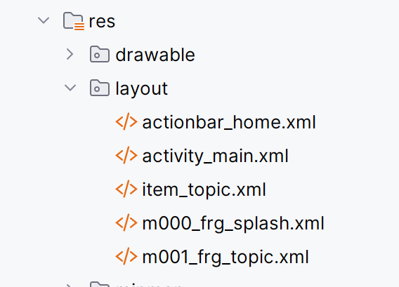

* File actionbar_home

*<?*xml version="1.0" encoding="utf-8"*?>*<LinearLayout xmlns:android="http://schemas.android.com/apk/res/android"  
 android:layout_width="match_parent"  
 android:layout_height="56dp"  
 android:orientation="horizontal"  
 android:background="@color/mainLight">  
  
 <ImageView  
 android:id="@+id/iv_back"  
 android:layout_width="56dp"  
 android:layout_height="56dp"  
 android:padding="12dp"  
 android:src="@android:drawable/ic_media_previous"  
 android:visibility="gone" />  
  
 <TextView  
 android:id="@+id/tv_name"  
 android:layout_width="match_parent"  
 android:layout_height="match_parent"  
 android:gravity="center_vertical"  
 android:layout_marginStart="10dp"  
 android:text="Truyện cười 🤣"  
 android:textColor="@color/white"  
 android:textSize="22sp" />  
</LinearLayout>

* File Activity_main

<?xml version="1.0" encoding="utf-8"?>

<LinearLayout xmlns:android="http://schemas.android.com/apk/res/android"

android:id="@+id/ln_main"

android:orientation="vertical"

android:layout_width="match_parent"

android:layout_height="match_parent"/>

* File item_topic

<?xml version="1.0" encoding="utf-8"?>

<LinearLayout xmlns:android="http://schemas.android.com/apk/res/android"

android:layout_width="match_parent"

android:layout_height="wrap_content"

android:background="@color/white"

android:layout_marginBottom="10dp">

<ImageView

android:id="@+id/iv_topic"

android:layout_width="120dp"

android:layout_height="80dp"

android:scaleType="centerCrop"

android:src="@mipmap/ic_launcher" />

<TextView

android:id="@+id/tv_topic"

android:layout_width="match_parent"

android:layout_height="match_parent"

android:layout_marginStart="10dp"

android:gravity="center_vertical"

android:text="Giao thông"

android:textColor="@color/textDark"

android:textSize="20sp" />

</LinearLayout>

* M000_frg_splash

<?xml version="1.0" encoding="utf-8"?>

<FrameLayout xmlns:android="http://schemas.android.com/apk/res/android"

android:layout_width="match_parent"

android:layout_height="match_parent"

android:background="@color/mainPrimary">

<TextView

android:layout_width="wrap_content"

android:layout_height="wrap_content"

android:text="TRUYỆN CƯỜI 🤣"

android:textSize="26sp"

android:textColor="@color/white"

android:layout_gravity="center"/>

</FrameLayout>

* M001_frg_topic

*<?*xml version="1.0" encoding="utf-8"*?>*<LinearLayout xmlns:android="http://schemas.android.com/apk/res/android"  
 android:layout_width="match_parent"  
 android:layout_height="match_parent"  
 android:background="@color/mainBg"  
 android:orientation="vertical">  
  
 <include layout="@layout/actionbar_home" />  
  
 <ScrollView  
 android:layout_width="match_parent"  
 android:layout_height="match_parent">  
  
 <LinearLayout  
 android:id="@+id/ln_topic"  
 android:layout_width="match_parent"  
 android:layout_height="wrap_content"  
 android:orientation="vertical"  
 android:padding="10dp" />  
 </ScrollView>  
  
</LinearLayout>

Run 🡪 ra kết quả

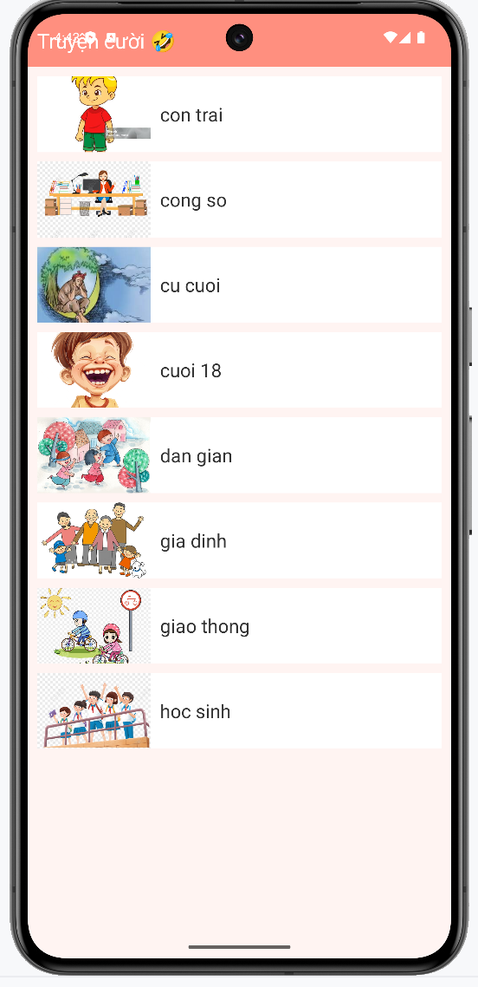

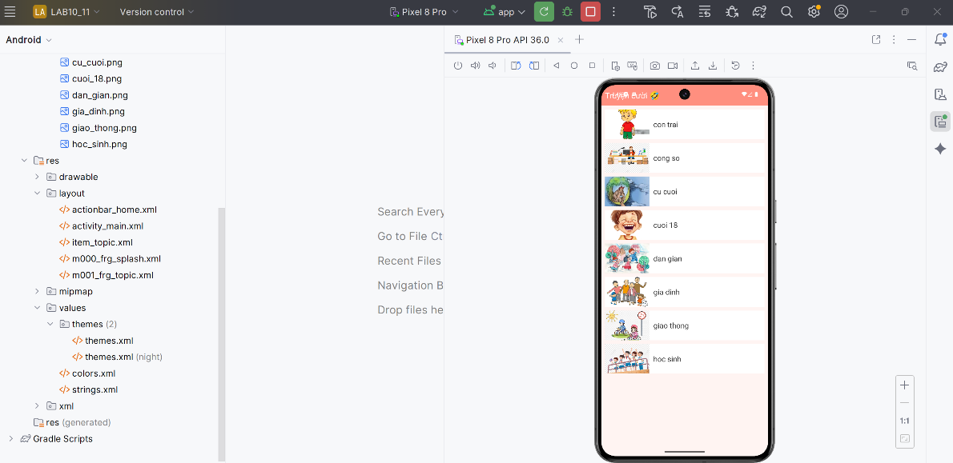

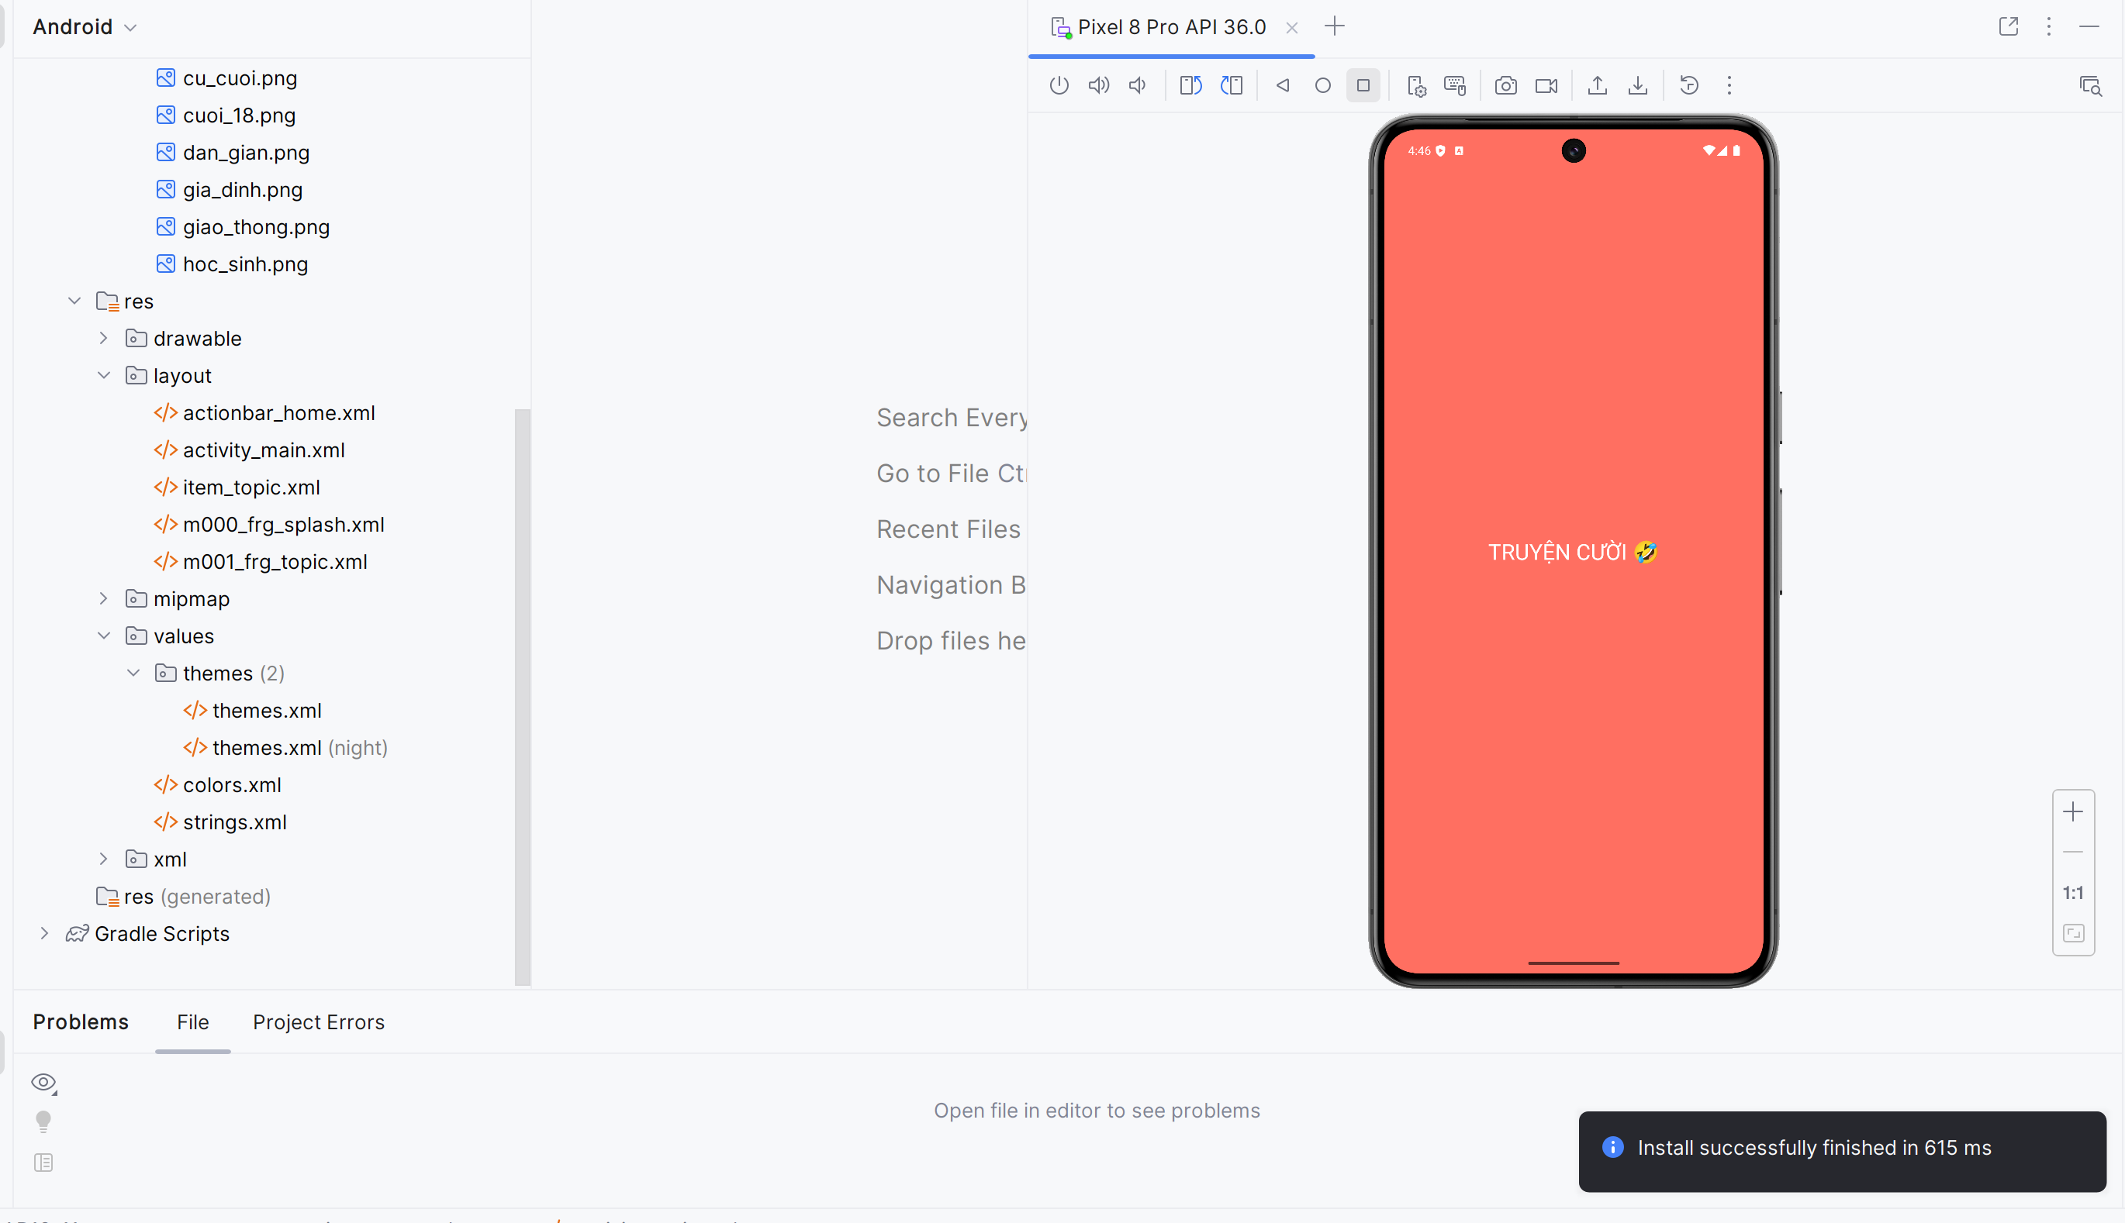

# BUỔI 5: BÀI TẬP THỰC HÀNH

## LAB_13_14

### LUYỆN TẬP_ XÂY DỰNG GIAO DIỆN ĐĂNG NHẬP/ ĐĂNG KÝ

Tạo file new projects 🡪 đặt tên file

Ở thư mục Values 🡪 colors.xml 🡪 thêm màu

|  |
| --- |
| <?xml version="1.0" encoding="utf-8"?>  <resources>  <color name="purple_200">#FFBB86FC</color>  <color name="purple_500">#FF6200EE</color>  <color name="purple_700">#F4511E</color>  <color name="teal_200">#FF03DAC5</color>  <color name="teal_700">#FF018786</color>  <color name="black">#FF000000</color>  <color name="white">#FFFFFFFF</color>  <color name="orange">#FB8C00</color>  <color name="orangeMid">#F4511E</color>  <color name="gray">#EAE5E3</color>  </resources> |

Tiếp tục chọn file kế bên strings 🡪 thêm các ký tự nhập trong form đăng ký/ đăng nhập

|  |
| --- |
| <resources>  <string name="app_name">lab13_14</string>  <string name="txt_login">Login</string>  <string name="hint_email">Email</string>  <string name="hint_password">Password</string>  <string name="txt_forgot_pass">Forgot password?</string>  <string name="txt_no_account">Do not have an account?</string>  <string name="txt_register">Register</string>  <string name="back_button">Back</string>  </resources> |

Ở mục drawable 🡪 tạo 3 file cho giao diện khung

* bg_login.xml

|  |
| --- |
| <shape xmlns:android="http://schemas.android.com/apk/res/android">  <solid android:color="@color/orange"/>  <corners android:radius="20dp"/>  </shape> |

* bg_radius.xml

|  |
| --- |
| <shape xmlns:android="http://schemas.android.com/apk/res/android">  <corners android:radius="20dp"/>  <solid android:color="#FFFFFF"/>  </shape> |

* bg_top.xml

|  |
| --- |
| <shape xmlns:android="http://schemas.android.com/apk/res/android">  <gradient  android:startColor="@color/orange"  android:endColor="@color/orangeMid"  android:angle="45" />  <cornersandroid:topLeftRadius="30dp" android:topRightRadius="30dp" />  </shape> |

Thư mục layout 🡪 mình sẽ tạo tiếp thêm hai file giao diện

M000_frg_login.xml

|  |
| --- |
| <?xml version="1.0" encoding="utf-8"?>  <LinearLayout xmlns:android="http://schemas.android.com/apk/res/android"  android:layout_width="match_parent"  android:layout_height="match_parent"  android:orientation="vertical"  android:background="@color/gray"  android:padding="30dp">    <FrameLayout  android:layout_width="match_parent"  android:layout_height="300dp">  <View  android:layout_width="match_parent"  android:layout_height="300dp"  android:background="@drawable/bg_top" />  <TextView  android:layout_width="wrap_content"  android:layout_height="wrap_content"  android:layout_gravity="end"  android:layout_marginTop="220dp"  android:layout_marginEnd="30dp"  android:text="@string/txt_login"  android:textColor="@color/white"  android:textSize="20sp" />  </FrameLayout>    <EditText  android:id="@+id/edt_email"  android:layout_width="match_parent"  android:layout_height="50dp"  android:layout_marginBottom="10dp"  android:background="@drawable/bg_radius"  android:drawableLeft="@drawable/ic_email"  android:drawablePadding="10dp"  android:hint="@string/hint_email"  android:inputType="textEmailAddress"  android:padding="10dp"  android:textSize="18sp" />    <EditText  android:id="@+id/edt_pass"  android:layout_width="match_parent"  android:layout_height="50dp"  android:layout_marginBottom="10dp"  android:background="@drawable/bg_radius"  android:drawableLeft="@drawable/ic_key"  android:drawablePadding="10dp"  android:hint="@string/hint_password"  android:inputType="textPassword"  android:padding="10dp"  android:textSize="18sp" />    <TextView  android:layout_width="wrap_content"  android:layout_height="wrap_content"  android:layout_gravity="end"  android:layout_marginTop="10dp"  android:layout_marginEnd="30dp"  android:text="@string/txt_forgot_pass"  android:textColor="@color/black"  android:textSize="18sp" />  <TextView  android:id="@+id/tv_login"  android:layout_width="match_parent"  android:layout_height="50dp"  android:layout_marginTop="40dp"  android:background="@drawable/bg_login"  android:gravity="center"  android:padding="10dp"  android:text="@string/txt_login"  android:textColor="@color/white"  android:textSize="18sp" />    <TextView  android:id="@+id/tv_register"  android:layout_width="wrap_content"  android:layout_height="wrap_content"  android:layout_gravity="center"  android:text="@string/txt_no_account"  android:textColor="@color/black"  android:textSize="14sp" />  </LinearLayout> |

M001_frg_register.xml

|  |
| --- |
| <?xml version="1.0" encoding="utf-8"?>  <LinearLayout xmlns:android="http://schemas.android.com/apk/res/android"  android:layout_width="match_parent"  android:layout_height="match_parent"  android:orientation="vertical"  android:background="@color/gray"  android:padding="30dp">    <FrameLayout  android:layout_width="match_parent"  android:layout_height="300dp">  <View  android:layout_width="match_parent"  android:layout_height="300dp"  android:background="@drawable/bg_top" />  <TextView  android:layout_width="wrap_content"  android:layout_height="wrap_content"  android:layout_gravity="end"  android:layout_marginTop="220dp"  android:layout_marginEnd="30dp"  android:text="@string/txt_register"  android:textColor="@color/white"  android:textSize="20sp" />  </FrameLayout>    <EditText  android:id="@+id/edt_email"  android:layout_width="match_parent"  android:layout_height="50dp"  android:layout_marginBottom="10dp"  android:background="@drawable/bg_radius"  android:drawableStart="@drawable/ic_email"  android:drawablePadding="10dp"  android:hint="@string/hint_email"  android:autofillHints="email"  android:inputType="textEmailAddress"  android:padding="10dp"  android:textSize="18sp" />    <EditText  android:id="@+id/edt_pass"  android:layout_width="match_parent"  android:layout_height="50dp"  android:layout_marginBottom="10dp"  android:background="@drawable/bg_radius"  android:drawableStart="@drawable/ic_key"  android:drawablePadding="10dp"  android:hint="@string/hint_password"  android:autofillHints="password"  android:inputType="textPassword"  android:padding="10dp"  android:textSize="18sp" />    <EditText  android:id="@+id/edt_re_pass"  android:layout_width="match_parent"  android:layout_height="50dp"  android:layout_marginBottom="10dp"  android:background="@drawable/bg_radius"  android:drawableStart="@drawable/ic_key"  android:drawablePadding="10dp"  android:hint="@string/hint_password"  android:autofillHints="password"  android:inputType="textPassword"  android:padding="10dp"  android:textSize="18sp" />    <TextView  android:id="@+id/tv_register"  android:layout_width="match_parent"  android:layout_height="50dp"  android:layout_marginTop="40dp"  android:background="@drawable/bg_login"  android:gravity="center"  android:padding="10dp"  android:text="@string/txt_register"  android:textColor="@color/white"  android:textSize="18sp" />    <ImageView  android:id="@+id/iv_back"  android:layout_width="56dp"  android:layout_height="56dp"  android:layout_marginTop="20dp"  android:src="@drawable/ic_back"  android:layout_gravity="start"  android:padding="10dp"  android:contentDescription="@string/back_button" />  </LinearLayout> |

activity_main.xml 🡪 đổi cho phù hợp

|  |
| --- |
| <?xml version="1.0" encoding="utf-8"?>  <LinearLayout xmlns:android="http://schemas.android.com/apk/res/android"  android:layout_width="match_parent"  android:layout_height="match_parent"  android:orientation="vertical"  android:background="@color/gray">  <FrameLayout  android:id="@+id/ln_main"  android:layout_width="match_parent"  android:layout_height="match_parent" />  </LinearLayout> |

File java 🡪 mình sẽ tạo thêm 2 file mới ở mục

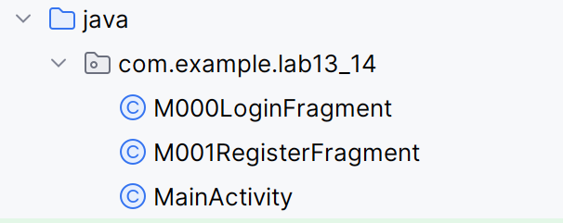

M000LoginFragment

|  |
| --- |
| package com.example.lab13_14;  import android.content.Context;  import android.content.SharedPreferences;  import android.os.Bundle;  import android.view.LayoutInflater;  import android.view.View;  import android.view.ViewGroup;  import android.view.animation.AnimationUtils;  import android.widget.EditText;  import android.widget.Toast;  import androidx.fragment.app.Fragment;  public class M000LoginFragment extends Fragment implements View.OnClickListener {  private EditText edtEmail, edtPass;  private Context mContext;  @Override  public View onCreateView(LayoutInflater inflater, ViewGroup container, Bundle savedInstanceState) {  View rootView = inflater.inflate(R.layout.m000_frg_login, container, false);  initView(rootView);  return rootView;  }  private void initView(View v) {  edtEmail = v.findViewById(R.id.edt_email);  edtPass = v.findViewById(R.id.edt_pass);  v.findViewById(R.id.tv_login).setOnClickListener(this);  v.findViewById(R.id.tv_register).setOnClickListener(this);  }  @Override  public void onClick(View v) {  v.startAnimation(AnimationUtils.loadAnimation(mContext, androidx.appcompat.R.anim.abc_fade_in));  if (v.getId() == R.id.tv_login) {  login(edtEmail.getText().toString(), edtPass.getText().toString());  } else if (v.getId() == R.id.tv_register) {  ((MainActivity) mContext).gotoRegisterScreen(); // Chuyển sang màn hình đăng ký  }  }  private void login(String mail, String pass) {  if (mail.isEmpty() || pass.isEmpty()) {  Toast.makeText(mContext, "Empty value", Toast.LENGTH_SHORT).show();  return;  }  SharedPreferences pref = mContext.getSharedPreferences(MainActivity.SAVE_PREF, Context.MODE_PRIVATE);  String savedPass = pref.getString(mail, null);  if (savedPass == null) {  Toast.makeText(mContext, "Email is not existed!", Toast.LENGTH_SHORT).show();  return;  }  if (!pass.equals(savedPass)) {  Toast.makeText(mContext, "Password is not correct!", Toast.LENGTH_SHORT).show();  return;  }  Toast.makeText(mContext, "Login account successfully!", Toast.LENGTH_SHORT).show();  }  @Override  public void onAttach(Context context) {  super.onAttach(context);  mContext = context;  }  } |

M001RegisterFragment

|  |
| --- |
| package com.example.lab13_14;  import android.content.Context;  import android.content.SharedPreferences;  import android.os.Bundle;  import android.view.LayoutInflater;  import android.view.View;  import android.view.ViewGroup;  import android.view.animation.AnimationUtils;  import android.widget.EditText;  import android.widget.Toast;  import androidx.fragment.app.Fragment;  import androidx.annotation.NonNull;  public class M001RegisterFragment extends Fragment implements View.OnClickListener {  private EditText edtEmail, edtPass, edtRePass;  private Context mContext;  @Override  public View onCreateView(LayoutInflater inflater, ViewGroup container, Bundle savedInstanceState) {  View rootView = inflater.inflate(R.layout.m001_frg_register, container, false);  initView(rootView);  return rootView;  }  private void initView(View v) {  edtEmail = v.findViewById(R.id.edt_email);  edtPass = v.findViewById(R.id.edt_pass);  edtRePass = v.findViewById(R.id.edt_re_pass);  v.findViewById(R.id.tv_register).setOnClickListener(this);  v.findViewById(R.id.iv_back).setOnClickListener(this);  }  @Override  public void onClick(View v) {    v.startAnimation(AnimationUtils.loadAnimation(mContext, R.anim.fade_in));  if (v.getId() == R.id.iv_back) {    ((MainActivity) mContext).gotoLoginScreen();  } else if (v.getId() == R.id.tv_register) {    register(edtEmail.getText().toString(), edtPass.getText().toString(), edtRePass.getText().toString());  }  }  private void register(String mail, String pass, String rePass) {  if (mail.isEmpty() || pass.isEmpty() || rePass.isEmpty()) {  Toast.makeText(mContext, "Please fill in all fields", Toast.LENGTH_SHORT).show();  return;  }  if (!pass.equals(rePass)) {  Toast.makeText(mContext, "Passwords do not match", Toast.LENGTH_SHORT).show();  return;  }    SharedPreferences pref = mContext.getSharedPreferences(MainActivity.SAVE_PREF, Context.MODE_PRIVATE);  String savedPass = pref.getString(mail, null);  if (savedPass != null) {  Toast.makeText(mContext, "Email already exists", Toast.LENGTH_SHORT).show();  return;  }    pref.edit().putString(mail, pass).apply();  Toast.makeText(mContext, "Account registered successfully!", Toast.LENGTH_SHORT).show();    ((MainActivity) mContext).gotoLoginScreen();  }  @Override  public void onAttach(@NonNull Context context) {  super.onAttach(context);  mContext = context;  }  } |

MainActivity.java

|  |
| --- |
| package com.example.lab13_14;  import android.os.Bundle;  import androidx.appcompat.app.AppCompatActivity;  import androidx.fragment.app.FragmentTransaction;  public class MainActivity extends AppCompatActivity {  public static final String SAVE_PREF = "save_pref";  @Override  protected void onCreate(Bundle savedInstanceState) {  super.onCreate(savedInstanceState);  setContentView(R.layout.activity_main);    gotoLoginScreen();  }    public void gotoLoginScreen() {    FragmentTransaction transaction = getSupportFragmentManager().beginTransaction();  transaction.replace(R.id.ln_main, new M000LoginFragment()); // ln_main là ID container trong activity_main.xml  transaction.commit();  }    public void gotoRegisterScreen() {  FragmentTransaction transaction = getSupportFragmentManager().beginTransaction();  transaction.replace(R.id.ln_main, new M001RegisterFragment()); // M001RegisterFragment cho màn hình đăng ký  transaction.commit();  }  } |

Run chạy ra kết quả

